PROTOCOL FOR PERFORMING DUTY BY HOUSEKEEPING STAFF IN

MAIN COMPLEX OF THE AKAL ACADEMY, BARU SAHIB

- Before entering inside the Hospital Complex, wash hands properly according to Govt guidelines.
- Immediately after entering the Hospital, put on a fresh laundered gown, a pair of 2 gloves and cover face with Clean Mask.
- Endorse Signature with name and time in the Register maintained at the Main Gate of Hospital.
- Sodium hypochlorite is available as 10% solution in the market and to prepared 1% sodium hypochlorite we have to follow the following procedure:
  - To make 1 liter solution take 900 ml of water and add 100ml of Sodium hypochlorite.(1Liter solution= 900ml H₂O+ 100ml NaClO)
  - Propyl Alcohol is available in market as 70% solution and there is no need to dilute it with water, we can use it directly.
Disinfection and Cleaning in various areas in the hospital is to be carried out with approved solution of disinfectants and water as per details given below:
AREAS | DISINFECTANT AGENTS TO BE USED FOR CLEANING OF TOILETS, FLOORS, OFFICES & ROOMS etc. | PROCEDURE
Toilet Pots  /Commodes | 1% Sodium Hypochlorite,  Toilet Brush & Hand Gloves  PROCEDURE:  Inside of toilets /commodes  Scrub with the recommended agents and toilet brush  Outside : Clean with agents | 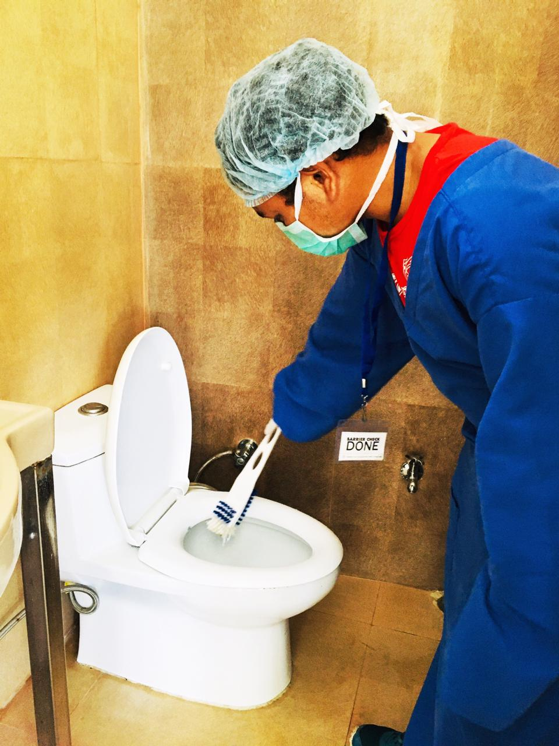
Wash Basins | 1% Sodium Hypochlorite, Surf Liquid & Scrubber  PROCEDURE:  Scrub with the recommended agents and scrubber  Wipes with 1% Sodium Hypochlorite | 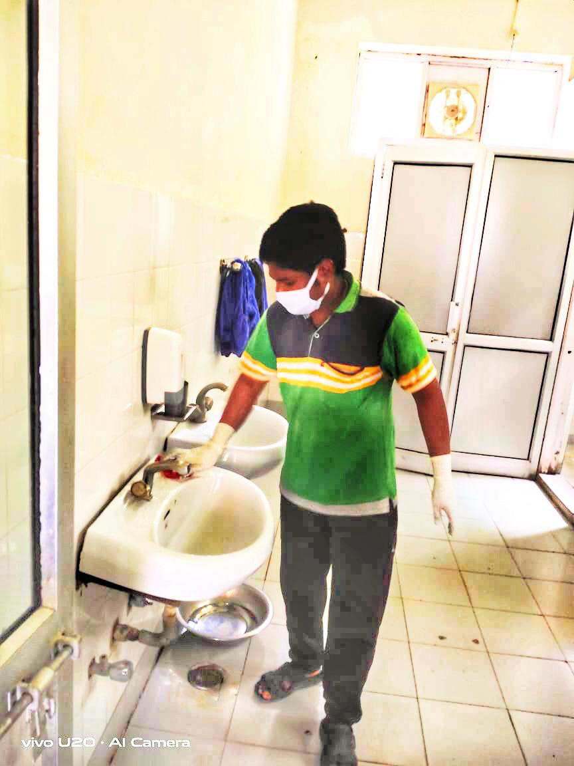
Toilet Floors | 1% Sodium Hypochlorite, Surf Liquid & Scrubber  PROCEDURE:  Scrub Floor with Surf Liquid and the scrubbing pad and wash with Sterimop and water | 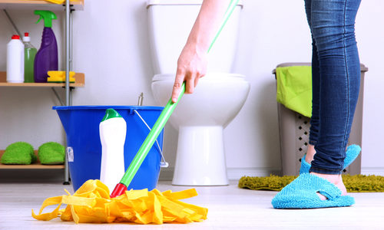
Toilet Walls | 1% Sodium Hypochlorite, Surf Liquid & Scrubber  PROCEDURE:  Scrub Floor with Surf Liquid and 1% Sodium Hypochlorite
Taps and Fittings | Warm Water, 1% Sodium Hypochlorite / 70% Propyl Alcohol & Scrubber  PROCEDURE:  Scrub with Surf Liquid  Wash with Warm Water /wipe with 1% Sodium Hypochlorite / 70% Propyl Alcohol | 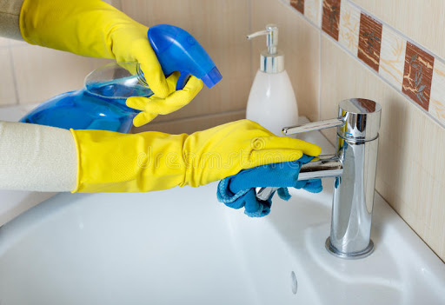
Staircases | 1% Sodium Hypochlorite, Surf Liquid & Scrubber  PROCEDURE:  Scrub with Surf Liquid /wash with Sterimop / 1% Sodium Hypochlorite | 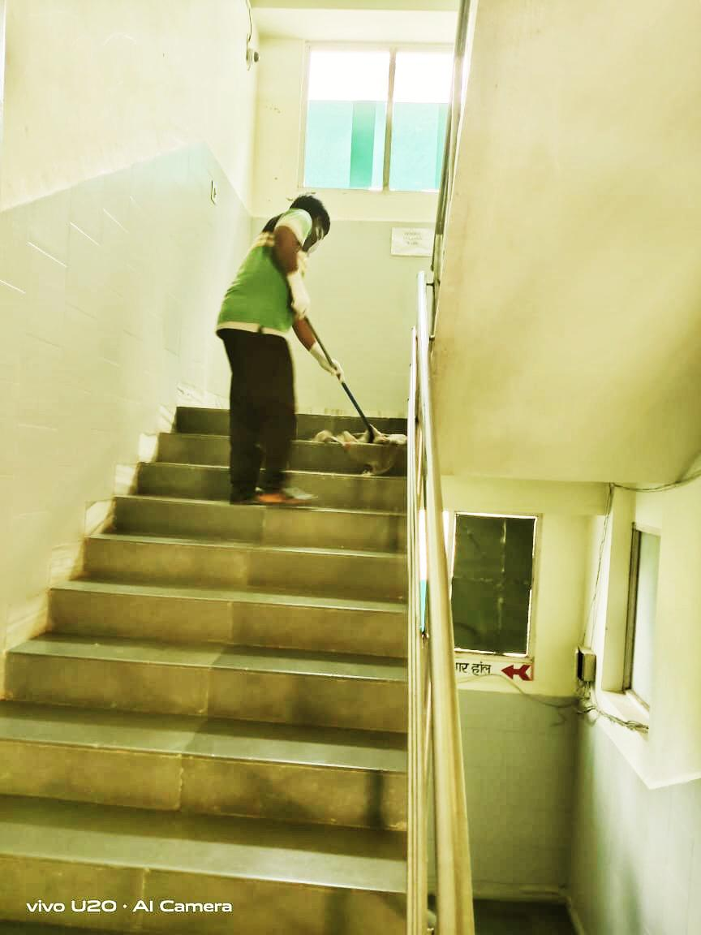
Floors/ Ward Nursing Stations / Dental Rooms/ OPD’s & OT’s | 1% Sodium Hypochlorite / Surf Liquid /Harpik, Sterimop,  Moping Cloth, Hand Gloves, Scrubber, Wiper, Bucket & Mug  PROCEDURE:  Scrub Floor with Surf Liquid and the Scrubbing Pad / wash with Sterimop and Water  Use Harpik 1% for Floor Wash | 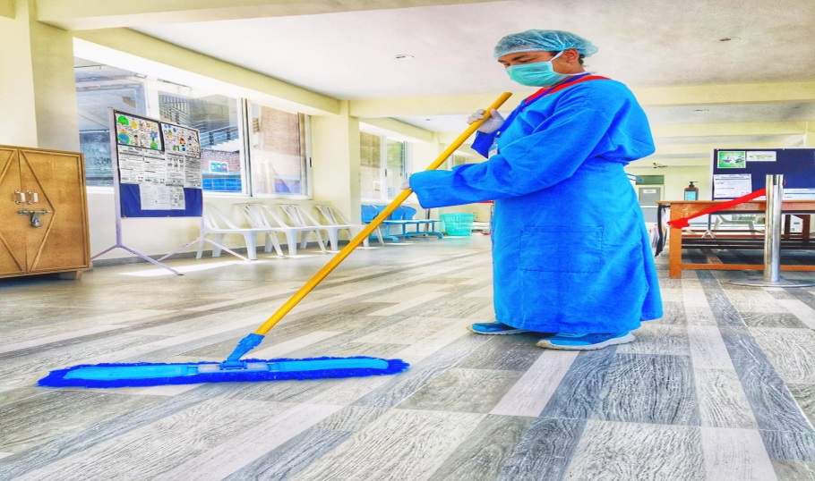
Handles and boards | 70% Propyl Alcohol / 1% Sodium Hypochlorite  Wipe with 1% Sodium Hypochlorite / 70% Propyl Alcohol | 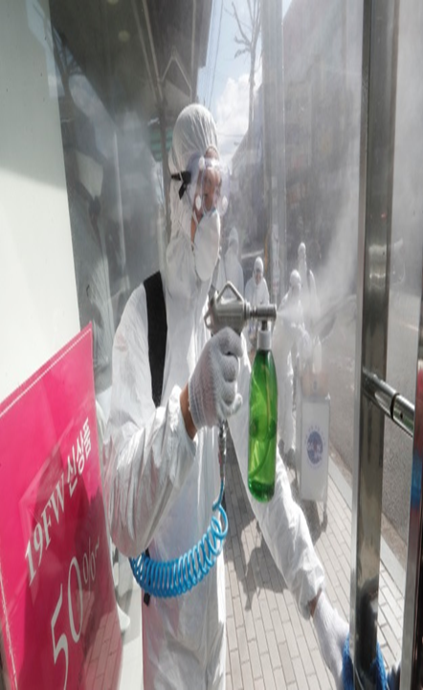
Tables & chairs

Record of having taken proper disinfectants and cleaning action in respect of various areas mentioned above is endorsed and signed in the house keeping maintenance register kept at the entrance gate of main complex of the Akal Academy.

Col. PPS Anand (Veteran) Mr. Santosh Shukla
HOD Incharge
Akal Housekeeping Services Akal Housekeeping Services

