PROTOCOL FOR PERFORMING DUTY BY AKAL HOUSE KEEPING STAFF AT THE MAIN BARRIER COMPLEX OF BARU SAHIB

- After reporting for duty at the Barrier Gate, details of Name, Time & Signature of the Housekeeping Staff are endorsed in the Housekeeping Maintenance Register placed at the Barrier Main Office.
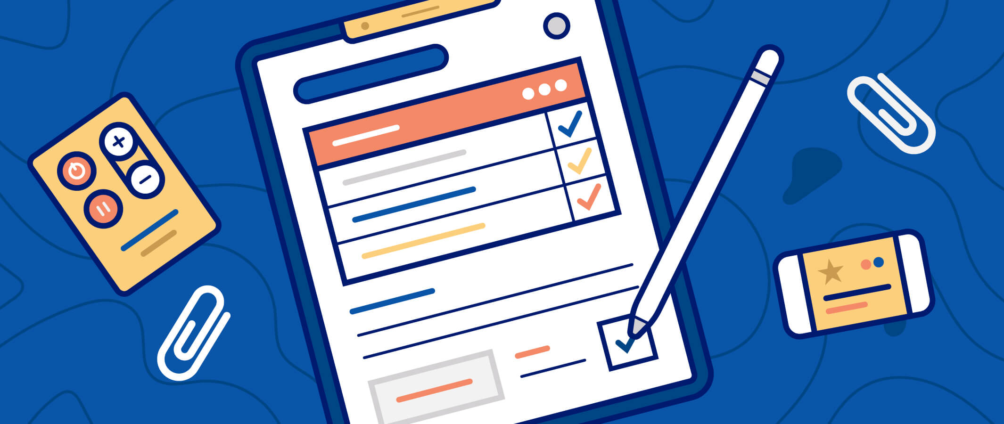

- He ensures that his hands are properly washed as per COVID-19 guidelines.
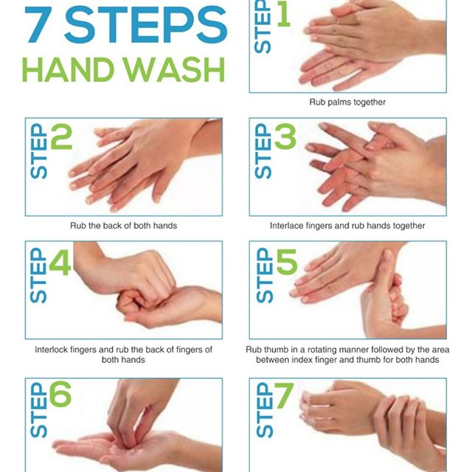

- Ensure that all vehicles arriving outside the Barrier Gate are thoroughly Sanitized with Propyl Alcohol 70% / Sodium Hypochlorite 5%, both inside and outside the vehicles concerned.
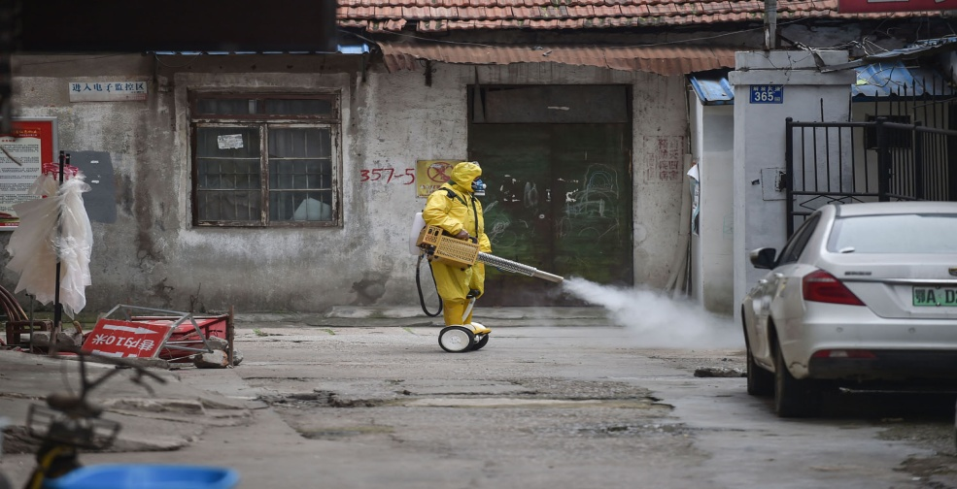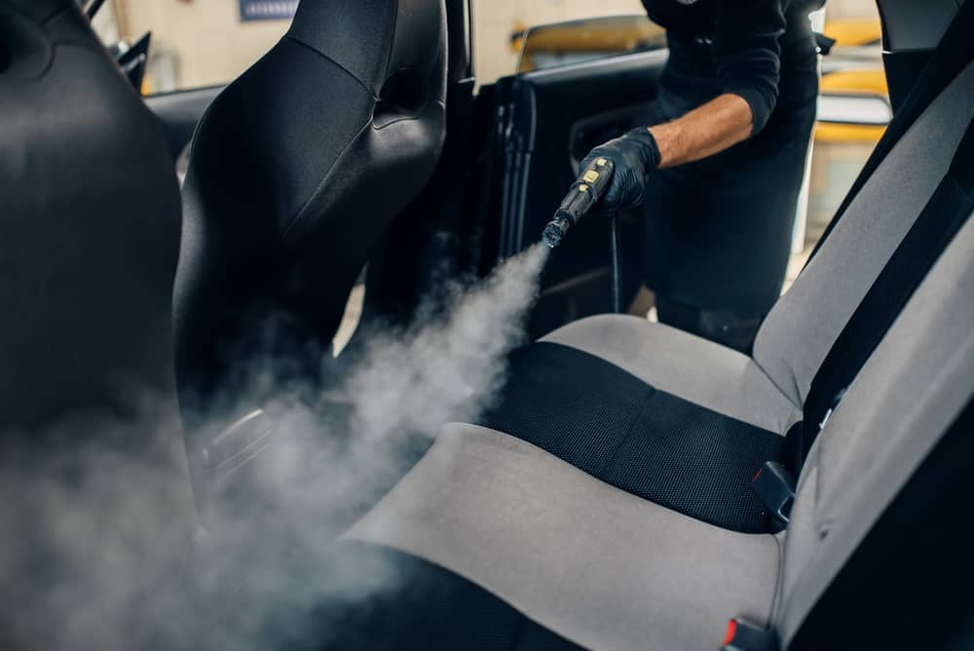
- To ensure that every individual seeking permission to come inside the Barrier Gate is guided to thoroughly wash his hands as per the COVID-19 Guidelines. Inform the O/ic Barrier Guard Post to interact with the visiting person concerned so as to educate that person the reason why no one is allowed to enter the Baru Sahib Complex during the Lockdown period. Alternatively, such person is guided by the said Guard Post O/ic to go inside the Main Barrier Single Window Office and explain/justify to the Single Window Staff on duty reason for his seeking permission to come inside the Baru Sahib complex.

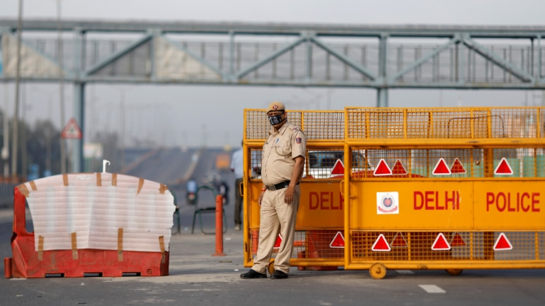

- Sweep all areas around the Barrier Complex with the help of big broom and thoroughly clean the Sewage Area.
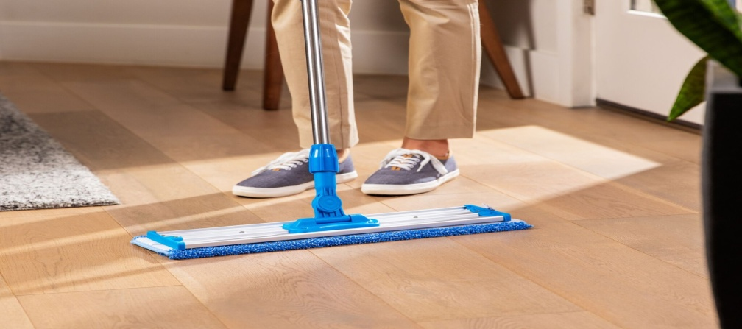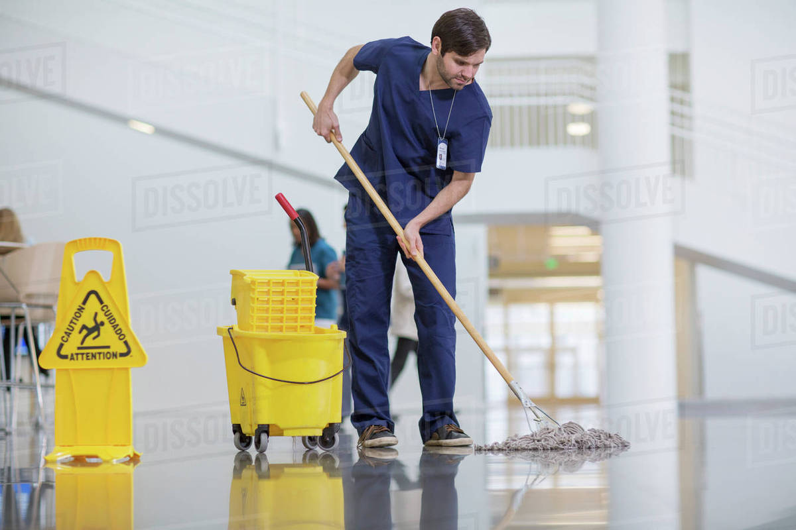
- Before starting to perform the allocated Housekeeping Cleaning duties in and around the Barrier Complex, ensure to disinfect all the cleaning equipment items like wipers, buckets, mugs etc.
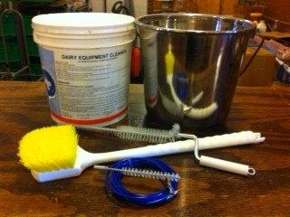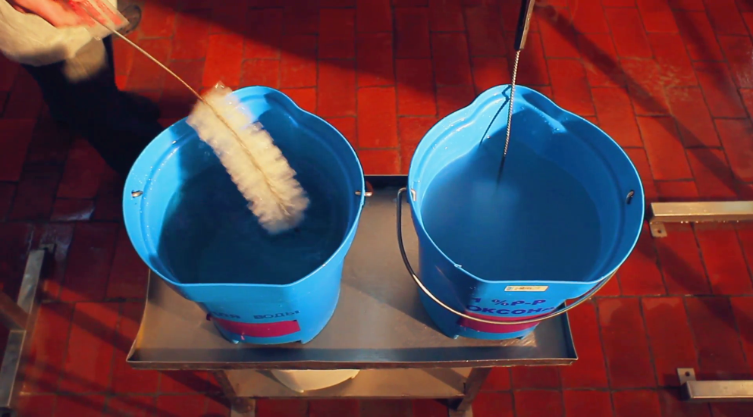
- Using a clean rag, sanitize all the surfaces in the Single Window Office Complex and pay special attention to surfaces which come into contact with hands (eg. Switch boards, phones, doors, cupboards, light switches, doors & windows handles, wash basins, water taps, tables, chairs and window panes).
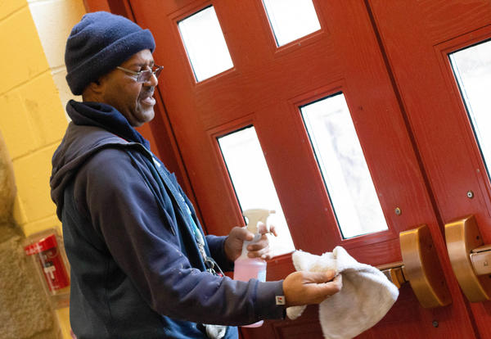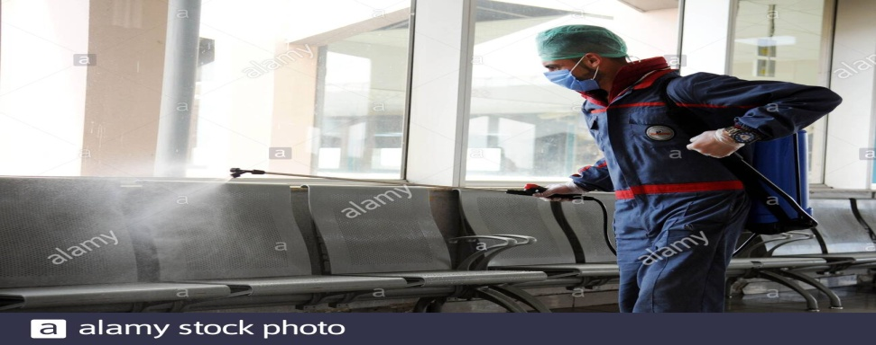
- Clean all washrooms located at this complex in the usual manner with special attention given to surfaces which come in contact with hands eg. Door handles, light switches, sink handles, dispensers, toilet paper holders, toilet flushing handle and taps etc.
- After cleaning the toilet, discard the used facility approved disinfectant and water into the wash basin / toilet and flush it.

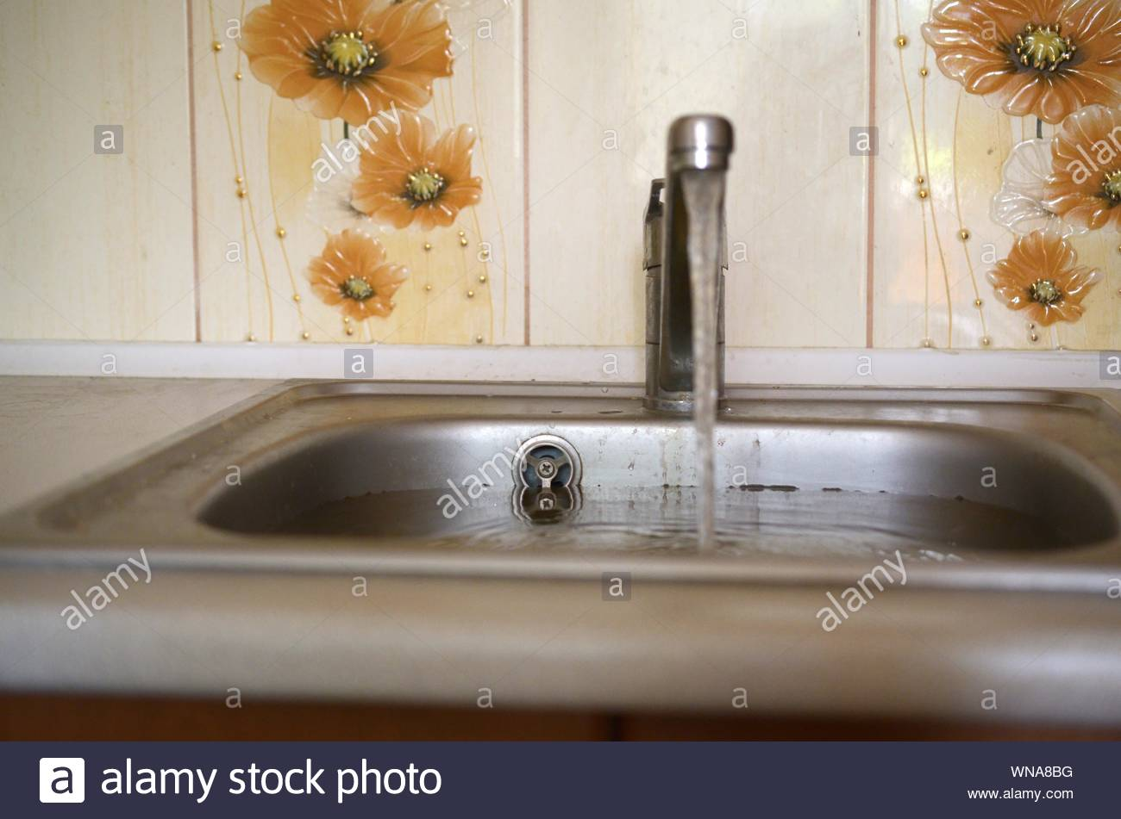
- Rinse the wash basin with hot water.
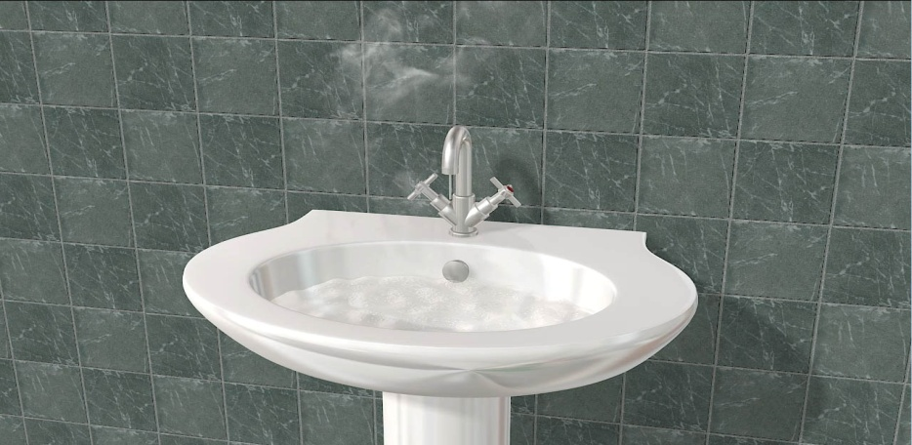

- First dry mop the floor areas.
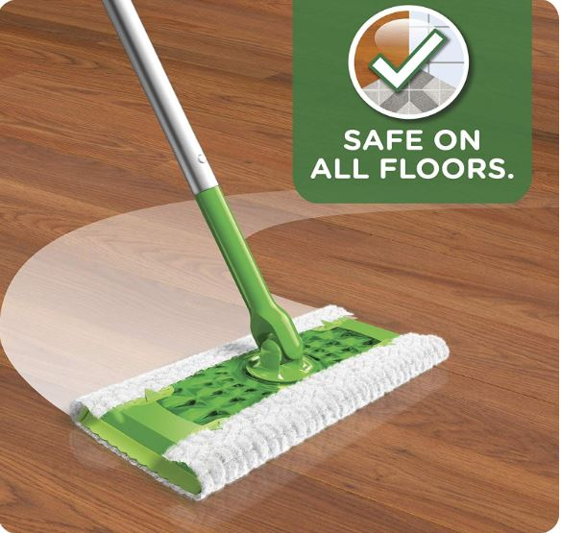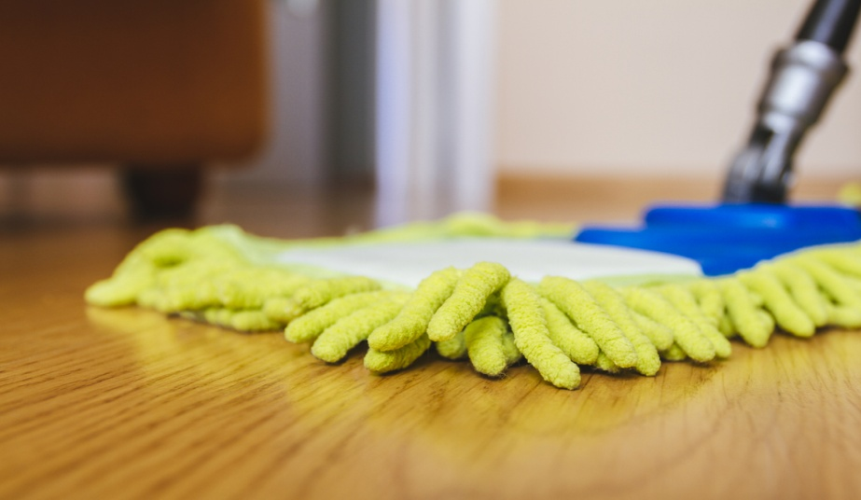
- Prepare a fresh solution (Sterimop) of facility disinfectant and water in the bucket to clean all floor areas.
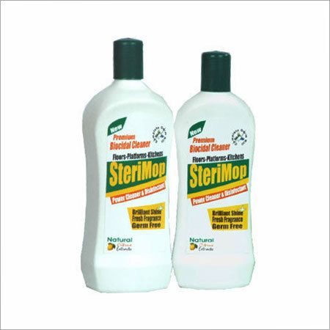
- Wash the floor with the clean mop head as per routine.
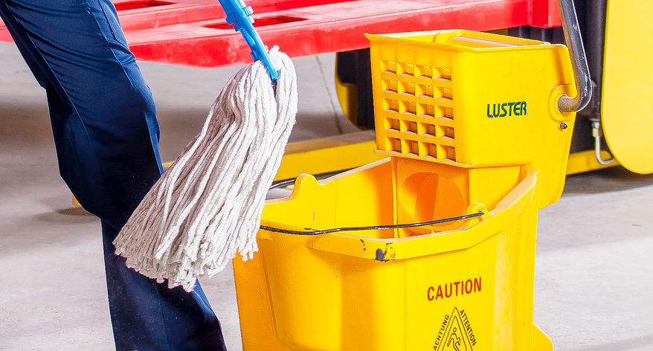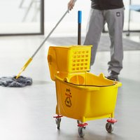
- After the floor is washed, pour the water into the toilet and flush it.
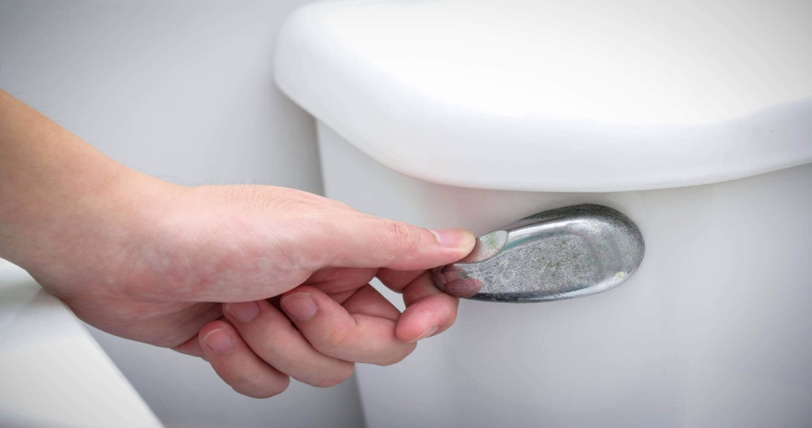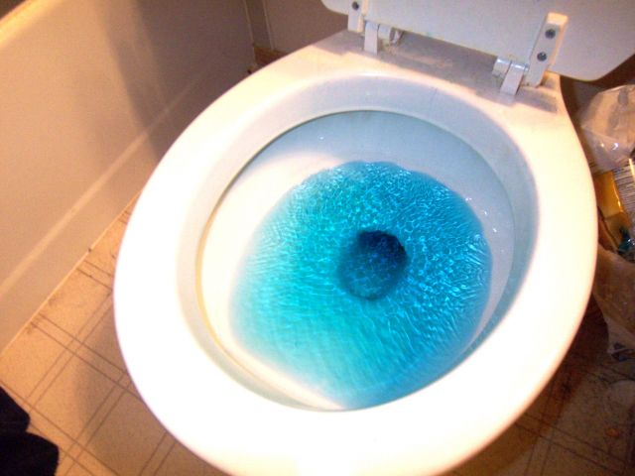

- Place the used rags into a clear plastic bag and drop in the dustbin kept in the office. Keep all other cleaning equipments at the allocated place in the office.
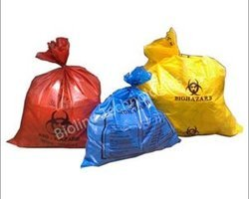
- Clean the dustbins by removing the existing garbage bag holding garbage waste, washing the dustbin and placing fresh garbage bag inside the dustbin.
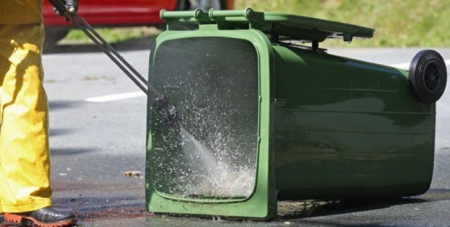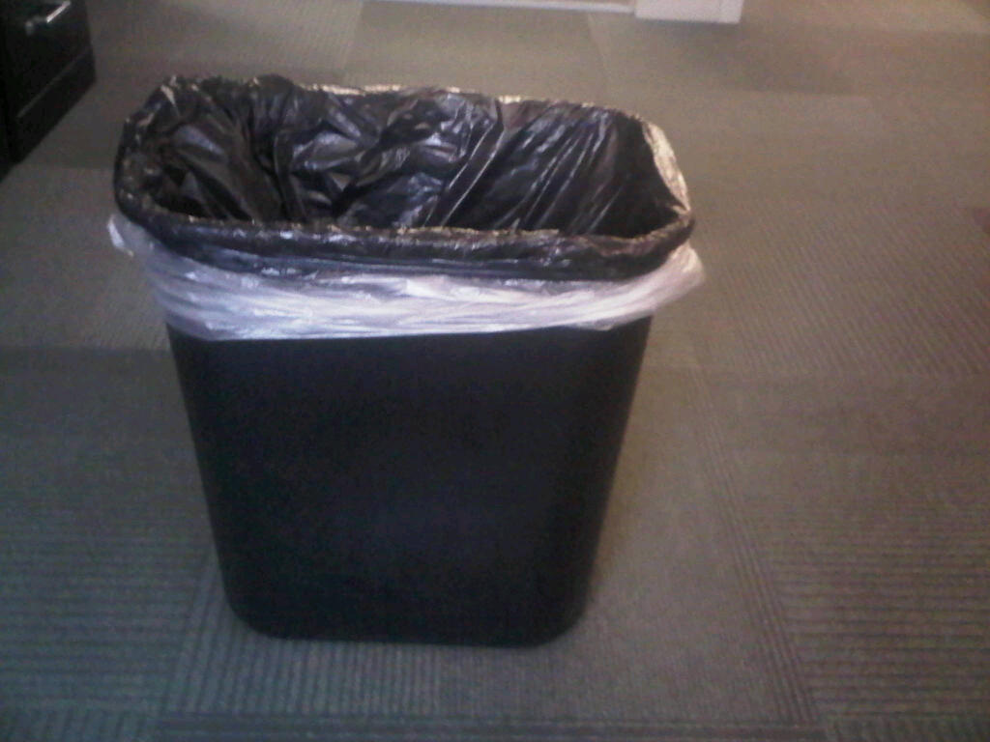
- Leave the room and when outside, wash hands for 20 seconds as per COVID-19 Guidelines.
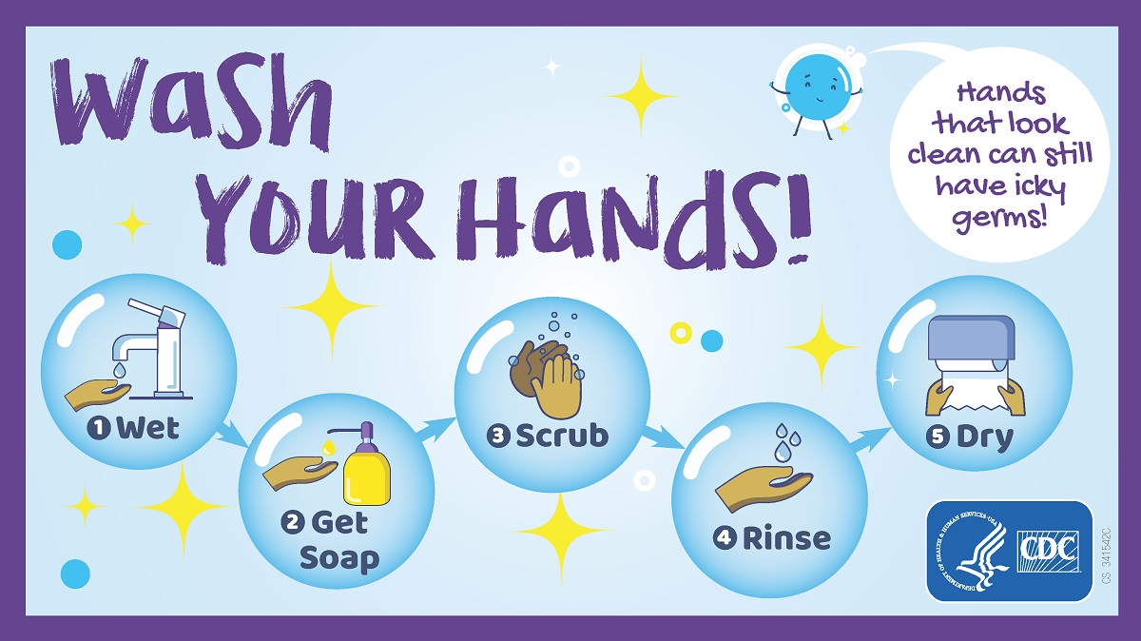
Records of having taken proper disinfecting & cleaning actions in respect of various areas mentioned above are endorsed & signed in the Housekeeping Maintenance Register kept at Single Window Office at the Barrier Complex.

Col. PPS Anand (Veteran) Mr. Santosh Shukla
HOD Incharge
Akal Housekeeping Services Akal Housekeeping Services

