PROTOCOL FOR PERFORMING DUTY BY HOUSEKEEPING STAFF IN AKAL CHARITABLE HOSPITAL COMPLEX, BARU SAHIB

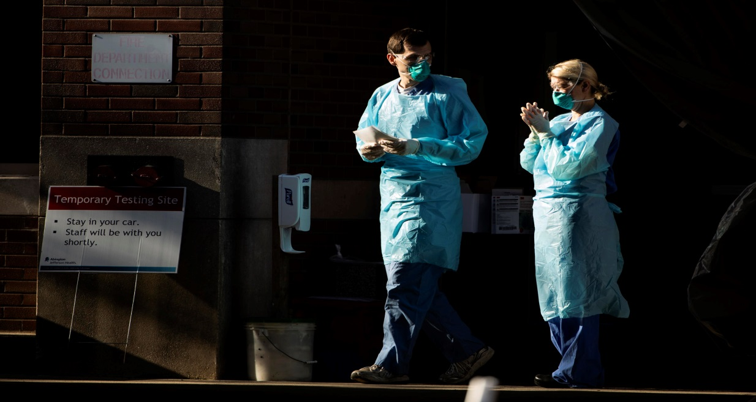
- Before entering inside the Hospital Complex, wash hands properly according to Govt guidelines.
- Immediately after entering the Hospital, put on a fresh laundered gown, a pair of 2 gloves and cover face with Clean Mask.
- Endorse Signature with name and time in the Register maintained at the Main Gate of Hospital.
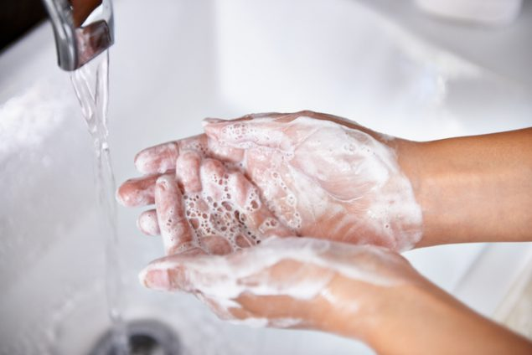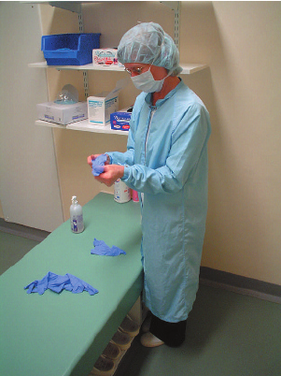

Disinfection and Cleaning in various areas in the hospital is to be carried out with approved solution of disinfectants and water as per details given below:

AREAS | DISINFECTANT AGENTS TO BE USED FOR CLEANING OF TOILETS, FLOORS, OFFICES & ROOMS etc. | PROCEDURE
Toilet Pots  /Commodes  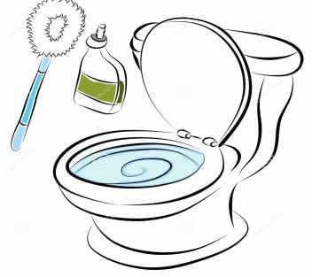 | 1% Sodium Hypochlorite,  Toilet Brush & Hand Gloves | Inside of toilets /commodes  Scrub with the recommended agents and toilet brush  Outside : Clean with agents
Wash Basins  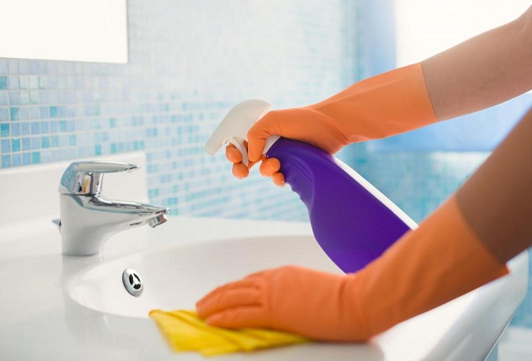 | 1% Sodium Hypochlorite, Surf Liquid & Scrubber | Scrub with the recommended agents and scrubber  Wipes with 1% Sodium Hypochlorite
ToiletWalls 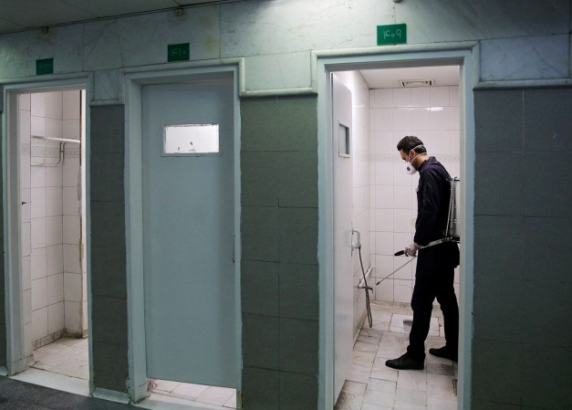 | 1% Sodium Hypochlorite, Surf Liquid & Scrubber | Scrub Floor with Surf Liquid and 1% Sodium Hypochlorite
Taps and Fittings  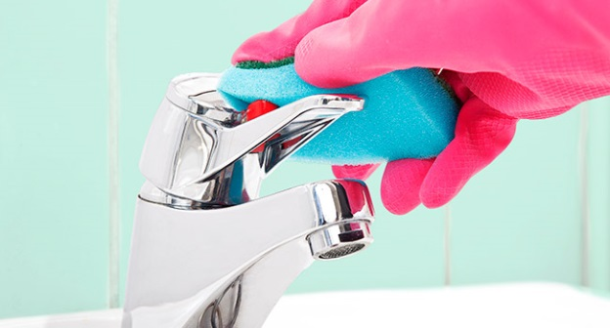 | Warm Water, 1% Sodium Hypochlorite / 70% Propyl Alcohol & Scrubber | Scrub with Surf Liquid  Wash with Warm Water /wipe with 1% Sodium Hypochlorite / 70% Propyl Alcohol
Staircases  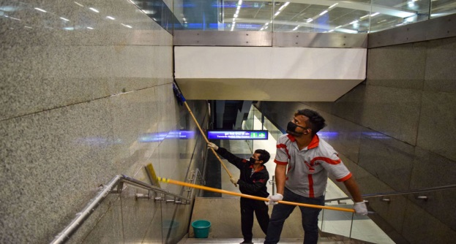 | 1% Sodium Hypochlorite, Surf Liquid & Scrubber | Scrub with Surf Liquid /wash with Sterimop / 1% Sodium Hypochlorite
Floors/ Ward Nursing Stations / Dental Rooms/ OPD’s & OT’s  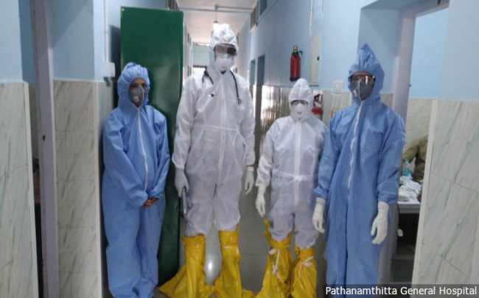 | 1% Sodium Hypochlorite / Surf Liquid /Harpik, Sterimop,  Moping Cloth, Hand Gloves, Scrubber, Wiper, Bucket & Mug | Scrub Floor with Surf Liquid and the Scrubbing Pad / wash with Sterimop and Water  Use Harpik 1% for Floor Wash
Handles & Boards etc.  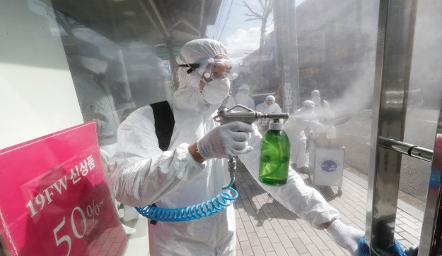 | 70% Propyl Alcohol / 1% Sodium Hypochlorite | Wipe with 1% Sodium Hypochlorite / 70% Propyl Alcohol

Collection of Bio-Medical Waste from Various Areas and Storage in Bio-Medical Waste Central Storage Area:
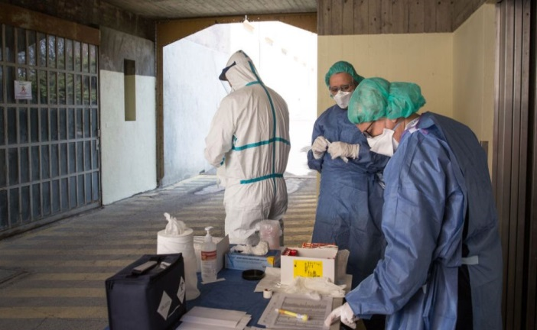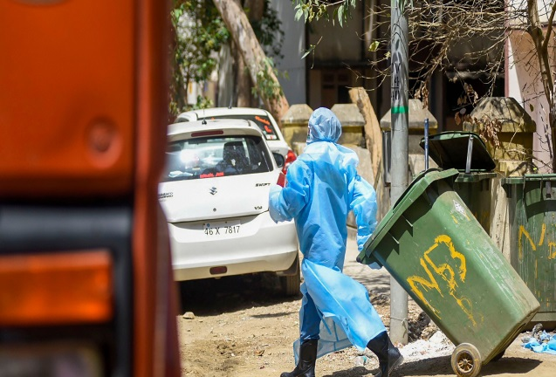

- Bio-Medical Waste is to be collected on daily basis from each Ward/ Nursing Station/ Pharmacy/ Dental Rooms/ OPD’s and OT’s in the hospital at a fixed interval of time every day.
- Bio Medical Waste at Akal Charitable Hospital is Handled, Segregated, Mutilated, Disinfected, Stored, and Transported and finally disposed of according to Bio-Medical Waste Management and Handling Rules, 2011.
- After collection, BMW is carried and stored in specially designed BMW Garbage Central Store House.
- SHARP items are collected and treated as per Bio-Medical Rules and after putting them in appropriate Colour Code Dustbins are carried and stored in BMW Central Storage Area.
- All BMW items are stored in Central Storage Area as per Bio-Medical Storage guidelines and are duly recorded in the BMW Storage Register on daily basis.
- As and when adequate stock of each Bio-Medical Waste item is held in the respective Colour Code Dustbins, entire disposal stock held in these Dustbins is transferred to Bio-Medical Waste Final Disposal Complex where this wastage is finally disposal off as per Govt. Guidelines.

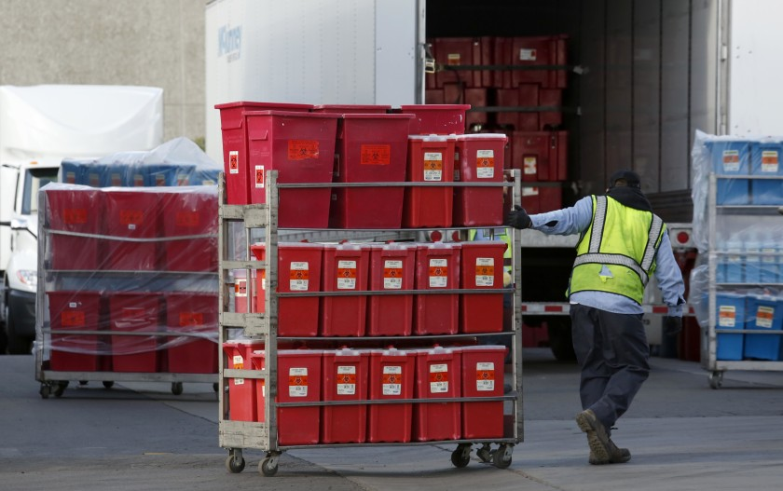

COLOUR CODING & TYPE OF CONTAINERS FOR DISPOSAL OF BIO-MEDICAL WASTE
Colour Coding | Type of Containers | Waste Category | Treatment Options as per Schedule
Yellow | Plastic Bag | 1,2,3,6 | Incineration/Deep Burial
Red | Disinfected Container/ Plastic Bag | 3,6,7 | Autoclaving/Micro Waving/ Chemical Treatment
Blue/ White Translucent | Plastic Bag/Puncture Proof Container | 4,7 | Autoclaving/Micro Waving/ Chemical Treatment and Destruction/Shredding

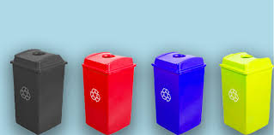

Bio-Medical Waste Management in Akal Charitable Hospital Baru Sahib
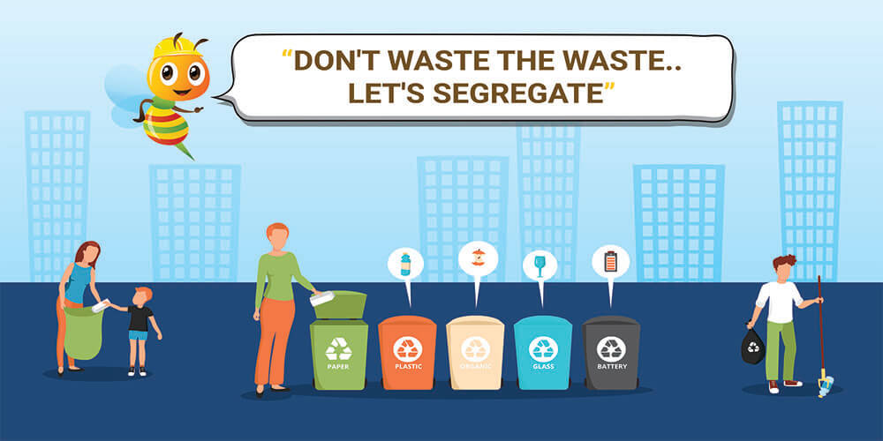
- Bio-Medical Waste is quite hazardous. Therefore it is very carefully managed.
Bio-Medical Waste at Akal Charitable Hospital is initially segregated in various categories and placed in the Colour Coded Dustbins approved for the respective category of Bio-Medical Waste.
- Various Categories of Bio-Medical Waste are chemically treated and using at least 1% Hypochlorite Solution or any other equivalent chemical agent and disposed of strictly according to the Govt. approved Category Wise Disposal System.

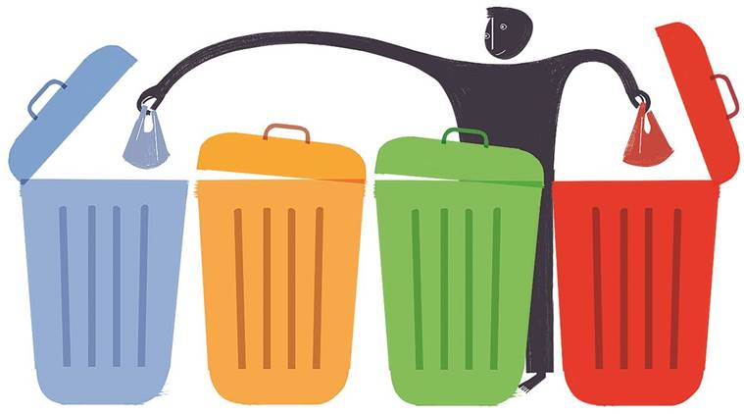

Disposal of Blood Contaminated Items Through Incineration Process
Our Incineration Complex consists of Double Chamber and Venturi, specially customized for Baru Sahib Complex. This is one of the best technically designed Gas Free System with Venturi Scrubber. The smoke emitted from it is not hazardous as it is Chemically Treated before releasing. All Category 1, 2, 3 & 6 Solid Waste items are disposed of by burning through the Incineration Process.
Category 1, 2, 3 & 6 Solid Waste are those items which are contaminated with blood and body fluids including cottons, dressings, soiled plaster casts, line bedding items and other blood contaminated materials like ladies Sanitary Pads etc.

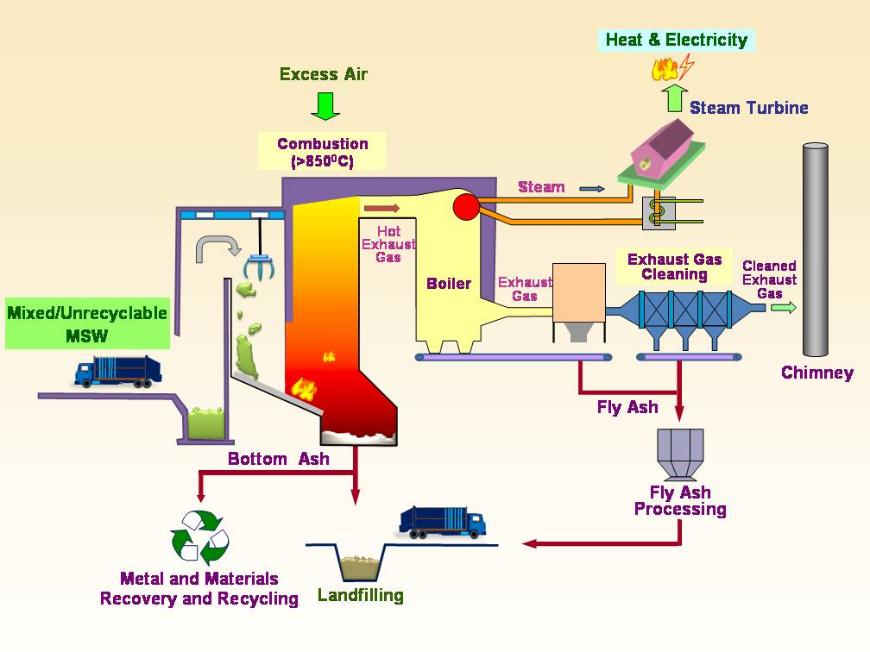

Syringe Mutilation Process
Syringe Mutilation Equipment comprises of a hollow pipe with an opening at the side from where the disinfected / treated Plastic Syringes are put in this pipe. Then they are crushed by a Solid Metal Pipe with a thrust with the help of a Lever. The crushed plastic material is expelled from another opening at the bottom. When enough stock of crushed plastic material is collected, it is sold as per weight.

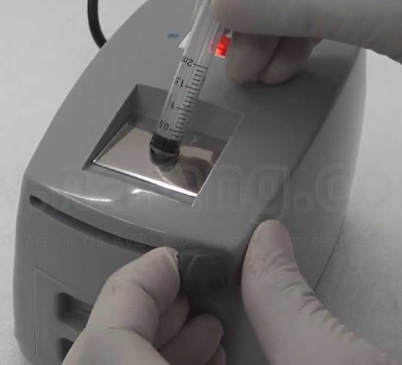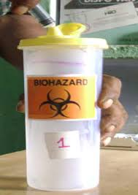

Autoclaving Process
An Autoclave Machine is used to treat Bio-Medical Waste of Category 3, 4, 6 and 7. Every day, this waste is placed in this machine where it is kept for about 15-20 minutes in a temperature measuring 121 Degree Celsius. This kills all the Micro Organisms present in the 3, 4, 6 and 7 Categories of Bio-Medical Waste
.
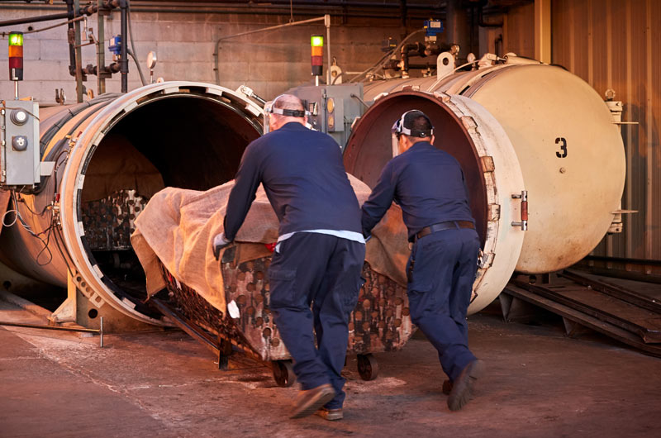

Disposal of Sharp Items
Needles, Blades, Glass Items etc. are coded as Red in Hospitals. They are immersed in 2% Bleach Solution for 48 hours. Then these are put in Autoclaving Machine for disinfecting. There after they are disposed of by putting them in the Sharp Disposal Unit. This Unit is a Cemented Pit constructed at a height but is away from the vicinity of any pipeline. A 4” covered pipe is placed on top of a hole through which all these Sharp Items are inserted into this Pit. Thereafter, this hole is covered with a heavy lid on top of it.
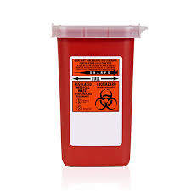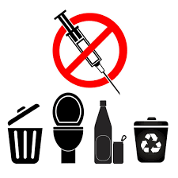

Record of taking proper action for above mentioned activities are endorsed in the Housekeeping Maintenance Register kept at the Bio-Medical Management Complex

