AKAL COLLEGE OF NURSING, ETERNAL UNIVERSITY
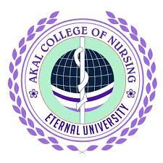
WORLD MENTAL HEALTH DAY (10TH OCTOBER)
REPORT
World Mental Health Day is observed on 10 October every year but we celebrated it on 9th October 2021.This day tries to create awareness about mental health issues. The theme for the World Mental Health Day 2021 was 'MENTAL HEALTH IN AN UNEQUAL WORLD. 'Mental health or psychological disorders are quite common in this day and age we are living in. Surveys suggest that around 14% of the population or 1 out of 7 individuals suffer from a psychological disorder. In India, this translates roughly to 200 million individuals. The most common mental health disorders are depressive disorders, anxiety disorders and substance abuse. About 50 million individuals in India suffer from depressive disorders and an equal number of people suffer from anxiety disorders. They can be seen across different stages in an individual's lifespan. However, depression, anxiety and eating disorders may be more commonly seen in women whereas substance abuse is more common in men. The elderly may be more prone to depressive disorders. It has also been seen that the underprivileged and uneducated population, may be more prone to psychological disorders. In children, an additional category of disorders such as developmental disorders may be seen. These include ADHD (attention deficit hyperactivity disorder), learning disabilities and autism spectrum disorders.
Organized by: Mental health nursing department of ACN &MPH Team
All the colleges from eternal university were invited to celebrate world mental health day. the invitation and activity planner was sent through e-mail to all the colleges. All the activities for the day were planned by nursing students under the guidance of team leaders of Mental Health Department given below:
HOD: Dr Anupama
Team Members: Dr.shweta
Ms Manpreet Kaur
Ms Komal Rana
Ms Manisha
Ms Suman
Theme: 'Mental Health in an Unequal World'
Participants : All students of ACN,AIRWE,ACP,ACM,ETERNAL UNIVERSITY and faculty +NSS students from EU university along with their teachers.
Venue: Eternal University Ground
Date: 9th Oct 2021
S.NO | ACTIVITY | TIME | STUDENTS
 | Rally | 4:10-5pm | B.Sc.Nursing 4th year
 | Street play | 3:30 pm -4:00pm | B.Sc.Nursing & MPH students
 | Refreshment | 4:00pm | For everyone lemon aid & snacks

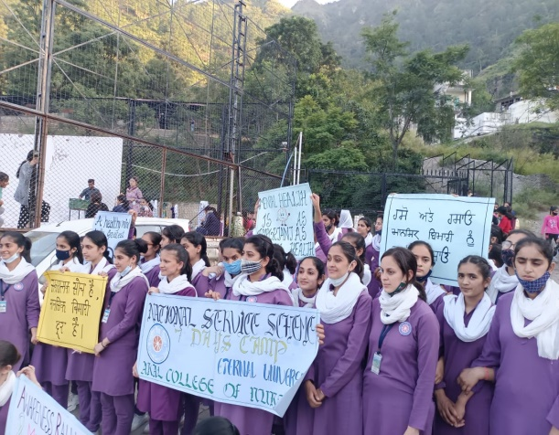
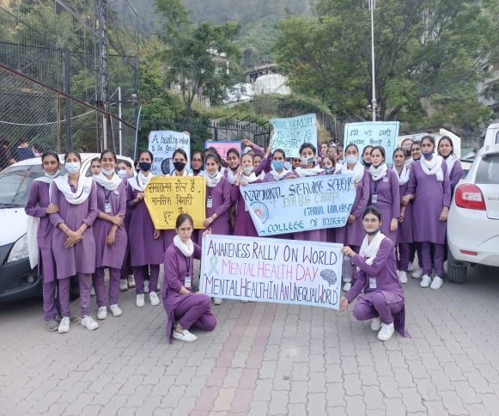

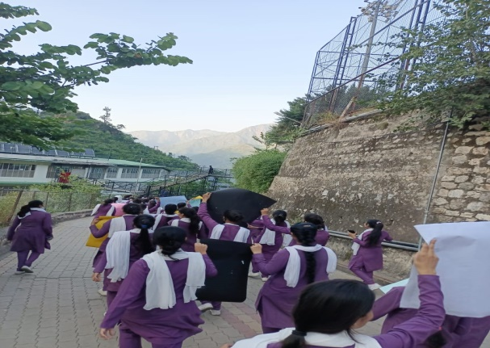
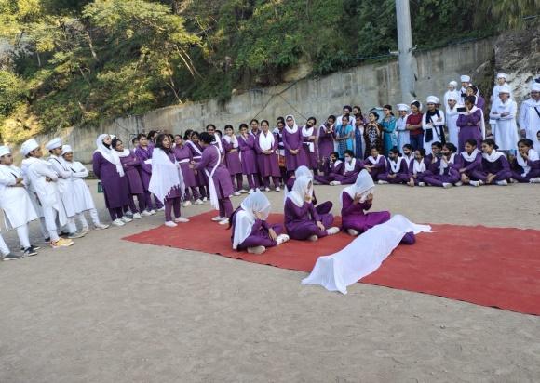
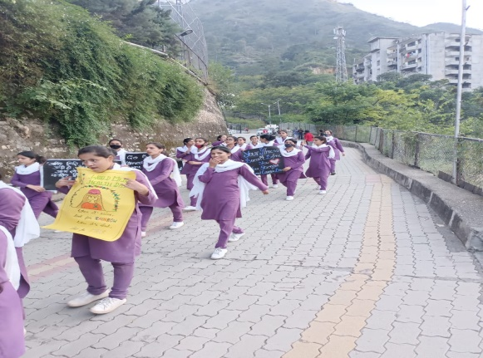
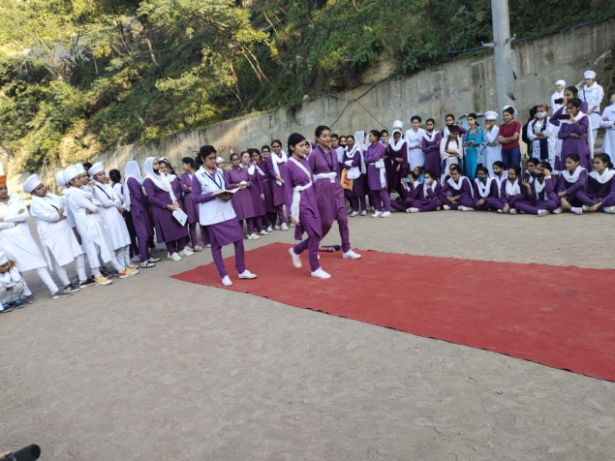
Signature of principal

