AKAL CHARITABLE HOSPITAL
(Parent Hospital)
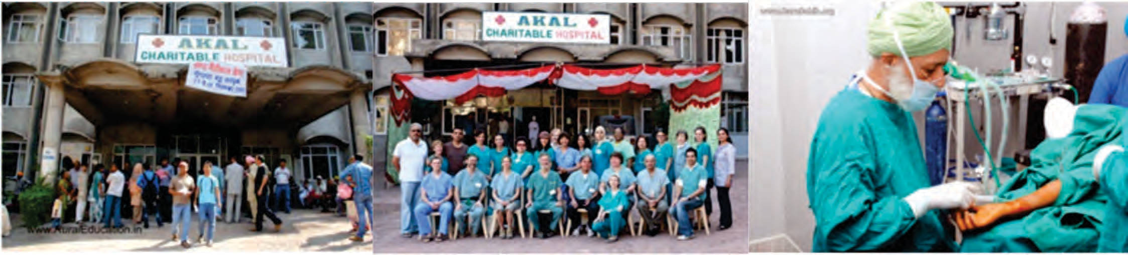
The Kalgidhar Trust also runs a 120 bedded Charitable Hospital in the backward district of Sirmour, Himachal Pradesh. It provide round the clock care to the students and staff members of campus as well as to the residents of this hilly area within a radius of 100 kms. More than 30,000 poor under privileged patients annually are attended with primary healthcare and emergency interventions.
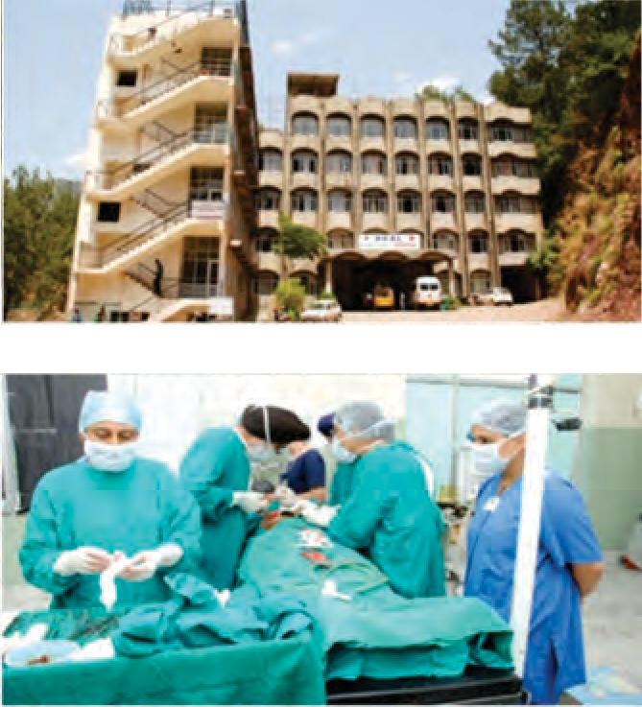
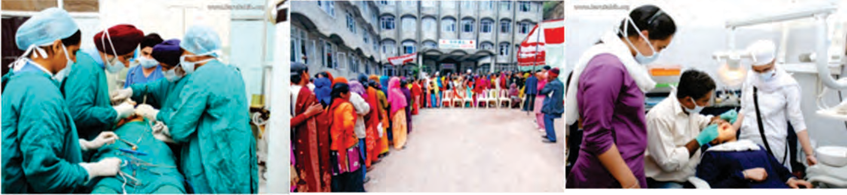
Four medical camps are held in Akal Charitable Hospital every year where in free expensive surgeries are provided to poor beneficiaries from remote areas of Himachal Pradesh, Haryana & Punjab by doctors from India and Abroad. At these camps, highly experienced doctors perform most advanced surgeries and provide high quality global care. These camps provide extra ordinary hands on professional experience to budding nursing students. The nursing students learn and pick up latest trends of international standards in the nursing care
Alternative Medicines:
  - Homeopathy
  - Ayurvedic
  - Acupressure
  - Naturopathy
  - Physiotherapy

Services Provided :
  - Internal Medicine and Cardiology
  - Ophthalmology
  - Ear Nose Throat
  - Gynecology and Obstetrics
  - Eye Surgery
  - General Surgery
  - ENT Surgery

