Akal College of Nursing
Eternal University, Baru Sahib, Dist. Sirmour-H.P.-173101

World Kidney Day-2022
Press Note:
Kidney is one of the vital organ of our body. The functions of this central organ includes filtration of blood, urine formation and many others. Its very essential in today's world to keep our kidney healthy, should know about the various kidney associated problems and its treatment concern. The World Kidney Day Joint Steering Committee has declared 2022 to be the year of “Kidney Health for All”. The theme of this year World Kidney Day is "Kidney Health for All" while focusing on increasing education and awareness about kidney health to bridge the gap at all levels of the healthcare system. Taking the same into consideration the first Nursing College of Himachal Pradesh; Akal College of Nursing, Eternal University has taken this initiative to make community aware about the kidney associated disorders and medical approach towards them through Street Play, health Talk (on incidence of Kidney diseases in India, world wide, causes, risk factors, treatment regimen) and rally.
The students of Akal College of Nursing under the direction of Baba Dr. Davinder Singh (Chancellor, EU), Dr. Amrik Singh Ahluwalia ( Pro Vice Chancellor, EU), Dr. Anupama (Principal, ACN, EU), Dr. Harpreet Kaur (Adm., ACN) & all other faculty members have worked towards achieving this goal and has motivated the students. The activities were organized in 3 distinct areas: Eternal University, Baru sahib, Indira Gandhi Medical College & Hospital, Shimla, Himachal Pradesh, Kamla Nehra Hospital, Shimla, Himachal Pradesh and Dr. Vidya Sagar Mental Hospital, Amritsar. Dr. Ravinder S. Mokta (MS. KNH), Dr. Ashish (HOD of Nephrology department, IGMC), Mrs. Premlata (NS, IGMC), Ward sister Mrs. Promil and staff nurses Mrs. Bhavna, Mrs. Sarika, Ms. Ayushi and Ms. Jyoti. Around 300 people have witnessed the rally at various places. Along with this various canopies were placed to check the B.P., HB status, weight & height of the community people. All the students have taken brilliant efforts while performing their duties.
KNH Shimla, H.P.
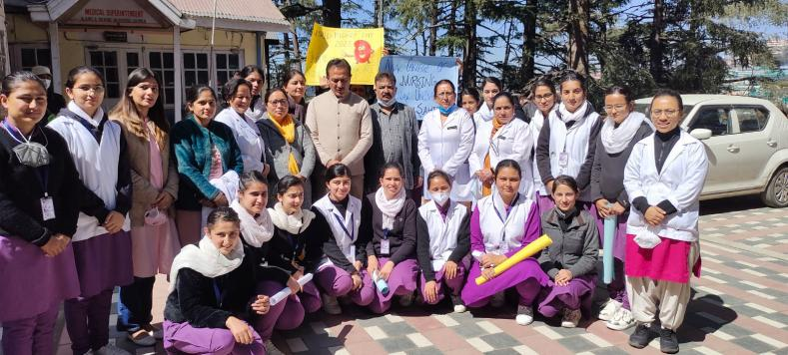
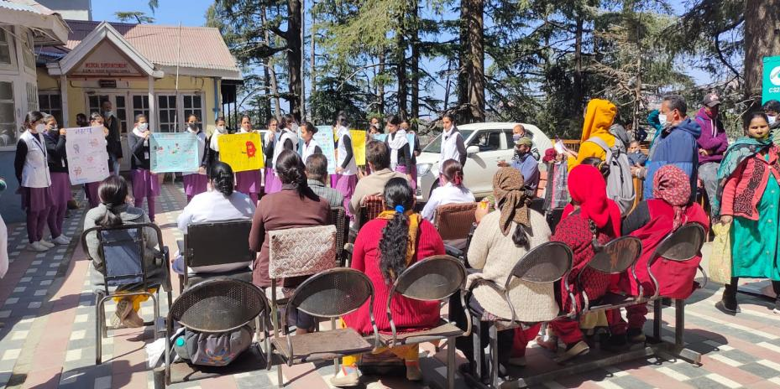
IGMC, Shimla, H.P.
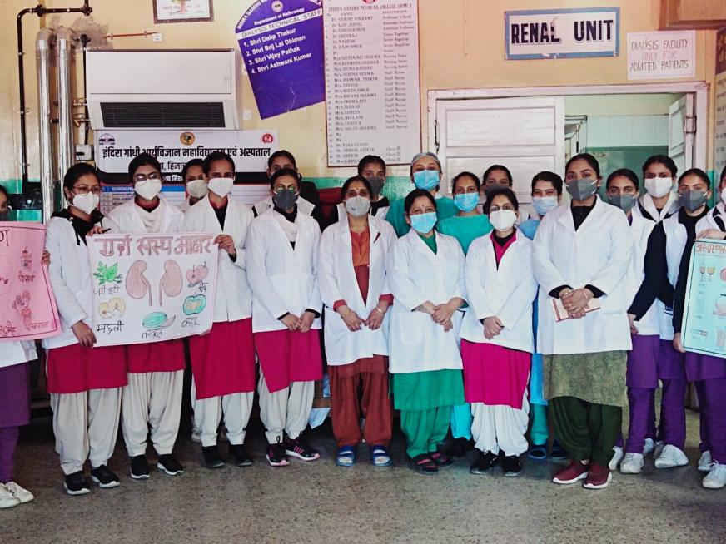
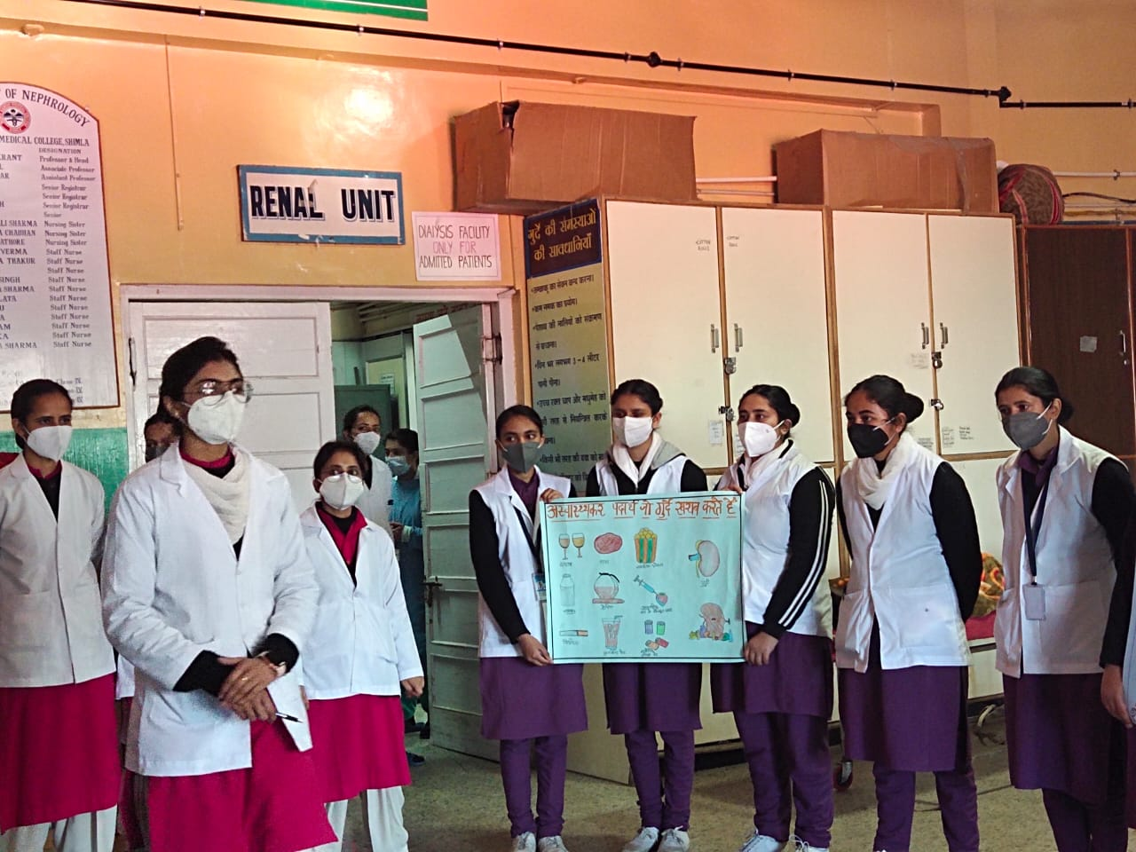
Eternal University, Baru Sahib, H.P.
