AKAL COLLEGE OF NURSING,
ETERNAL UNIVERSITY
BARU SAHIB

REPORT
OF
SCHOOL HEALTH PROGRAMME

SUBJECT: COMMUNITY HEALTH NURSING – II

Prepared By
MR.MUTHU KUMARAN
(ASSISTANT PROFESSOR)
Department of Community Health Nursing
Akal College of Nursing
2/12/2021

INTRODUCTION
BARU SAHIB also known as the “Valley of Divine Peace”, the land of meditation {tapobhoomi}, is the realization of the vision of SANT ATTAR SINGH JI, mastuane wale [1866-1927]. It spread over 400 acres and located in a remote corner of Himachal Pradesh, India, is ensconced amidst the sylvan surroundings of the Himalayas.
The students of B.Sc Nursing 4th year, Akal College of Nursing, Baru sahib conducted a school health program at model school from 22 November to 27 November 2021. Mr. Muthu Kumaran and Mrs Chanchal lata faculty of Community Health Nursing were guided the students for successfully carrying out the program.
There were around 250 students in the model school. During the visit observed the health conditions of the students and sanitation, ventilation in classrooms, environmental hygiene. This report on school health program will provide a short review about the health status of model school children.
OBJECTIVES:-
At the end of the school health program students are able to:
- Observe the infrastructure and health practice adopted by the model school.
- Conducting the health checkup
- Identifying the common health problem in school children.
- To provide awareness to students regarding the management of these problems.
- Gather data, analyze and interpret the findings in term of knowledge , practices regarding health in school.
- Appreciate working together as a team.
AKAL COLLEGE OF NURSING
ETERNAL UNIVERSITY
Baru Sahib, Rajgarh, Distt. Sirmaur, HP
SCHOOL HEALTH ACTIVITY SCHEDULE
DAY | DATE | ACTIVITY
Day 1 | 22/11/2021 | - Observation of School Facility  - Basic Health Check Up  - Basic Health Examination of students
Day 2 | 23/11/2021 | - Basic Health Check Up  - Basic Health Examination of students
Day 3 | 24/11/2021 | - Nutrition Day  - Exhibition on Nutritional food and nutritive items
Day 4 | 25/11/2021 | - Assessment of Knowledge on Existing Problem  - Teachers Meeting
Day 5 | 26/11/2021 | - Health Awareness Programme  - Health Related Play, Songs, Vegetable & Fruits Dance, Skit & Quiz  - Assessment of Knowledge after Health Education

DAY 1 : SCHOOL OBSERVATION
Name of school: Model School
School structure population: Male Students (79) : Female Students (91)
{total population=170}
Medium of language: Hindi , Punjabi, English
OBSERVATION OF SCHOOL
Health facilities at classroom:
appropriate | Lacking measures
Adequate space to work safely | Inadequate lighting
Clean and tidy classroom | Doors, windows, locks not present
Non slippery surface | Ventilation not appropriate

SAFE AND HEALTHY ENVIRONMENT
Appropriateness of parameter | Lacking parameter
Clean drinking water available. | toilet facilities not adequate
Teachers support those in distress | no dustbins in classroom
First aid box available | no canteen in school
Support available for teachers involved in violent incidents | No mid day meal scheme in operation

FIRE SAFETY AND EMERGENCY RESPONSE
Appropriateness of parameter | Lacking parameter
Fire control equipment is easily accessible | Audible evacuation alarm not present
School practice mock drill | Evacuation routes are not prominently displayed
HEALTH PROMOTING POLICIES AND PRACTICES IN SCHOOL
Appropriateness of parameter | Lacking parameter
There is proper liaisoning with health care providers | There is no health promotion policy
School promote health practices in community | There is no policy to tackle health emergencies

FAMILY AND COMMUNITY INVOLVEMENT
Appropriateness of parameter | Lacking parameter
School encourage family and community involvement | PTA does not address health issues
There is a functional parent teacher association

DAY 1 and DAY 2 : HEALTH ASSESSMENT
Vital statistics
SR.NO | GENDER | FREQUENCY | %
1 | MALE STUDENTS | 79 | 46.47
2 | FEMALE STUDENTS | 91 | 53.52

INFERENCES: The total number of students covered under health checkup are 170 out of which 46%are males and 53% are females.
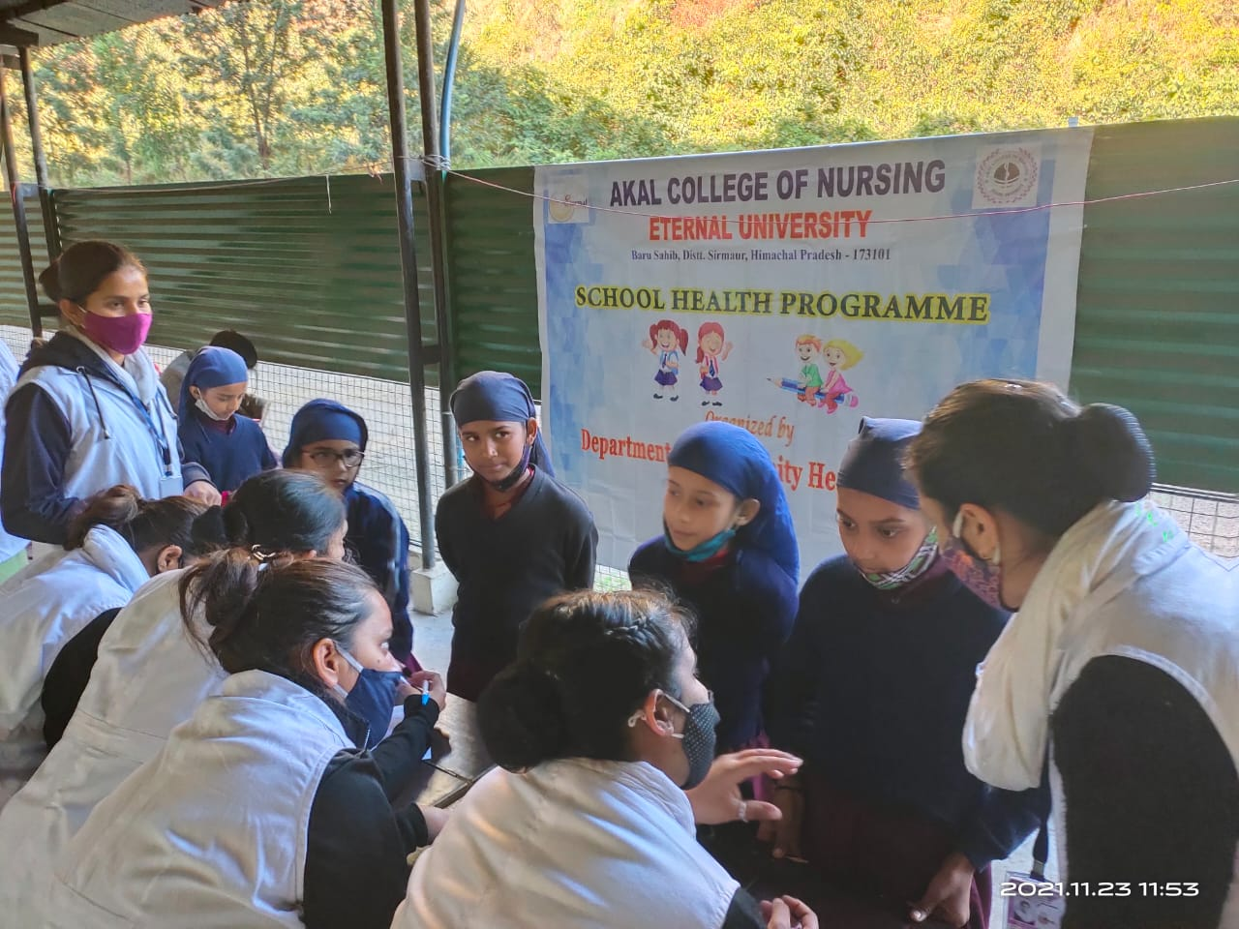
Anthropometric
SR.NO | DEGREE | FREQUENCY | %
1 | UNDERWEIGHT | 5 | 3
2 | OVERWEIGHT | 8 | 4
3 | OBESITY | 6 | 4
4. | NORMAL | 151 | 89

INFERENCES: out of 170 population of students 4% students are overweight, 2% are underweight and 3% are on risk.
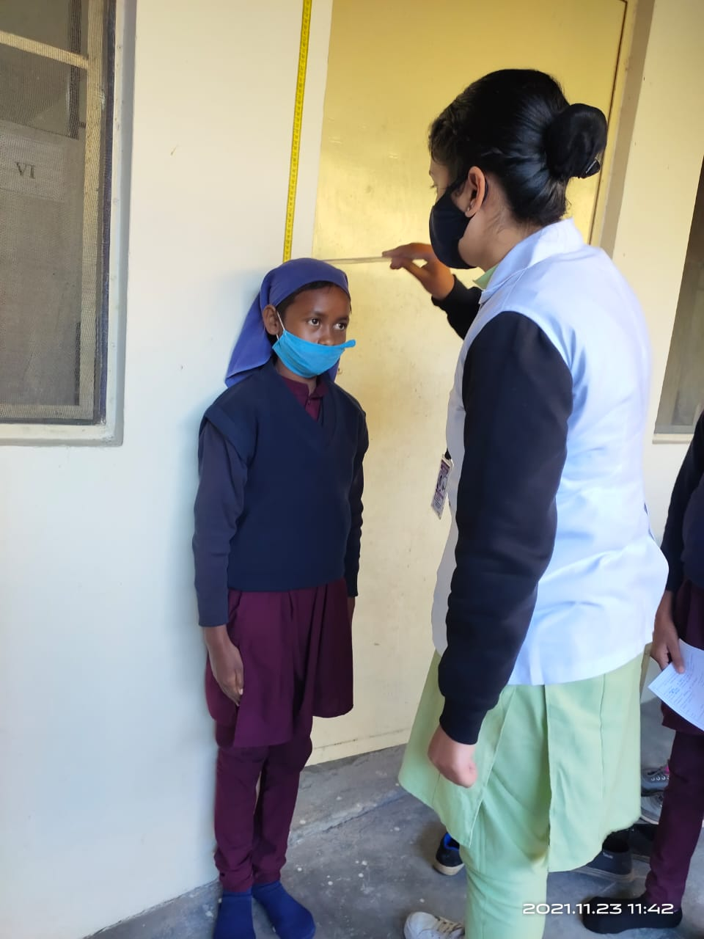
Eyes, nose , and throat examination
SR.NO | HEALTH CONDITION | FREQUENCY | %
1 | otalgia | 11 | 6.58
2 | Sore throat | 17 | 10
3 | epistaxis | 29 | 13.52
4 | tonsillitis | 15 | 8.82

INFERENCES: out of 170 students 6.5% are having otalgia, 10% are having sore throat and 13.52 % students have epistaxis and 8.82% are having tonsilitis.
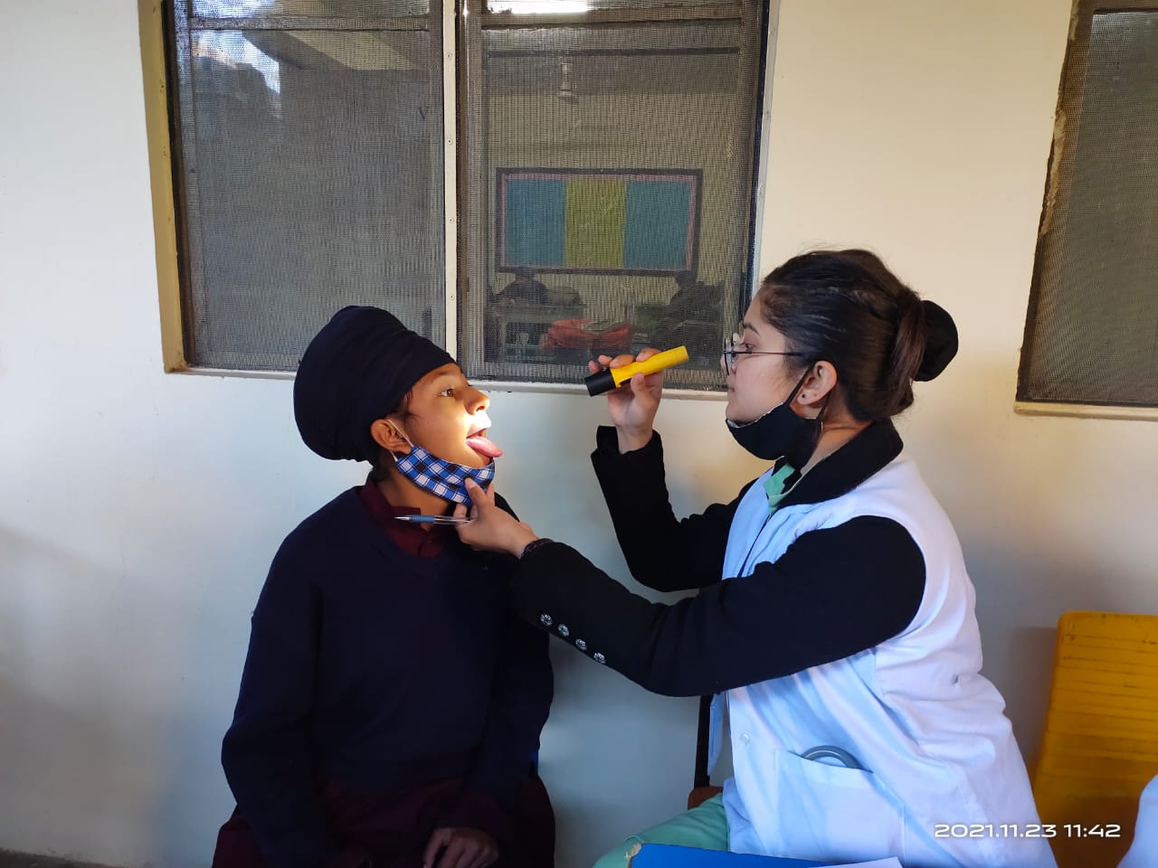
Dental health
Total:170
SR.NO | DENTAL HEALTH | FREQUENCY | %
1 | Dental carries | 98 | 57.64
2 | Toothache | 32 | 18.82

INFERENCES: out of 170 students 57.64% are having dental carries and 18.82 are having toothache.
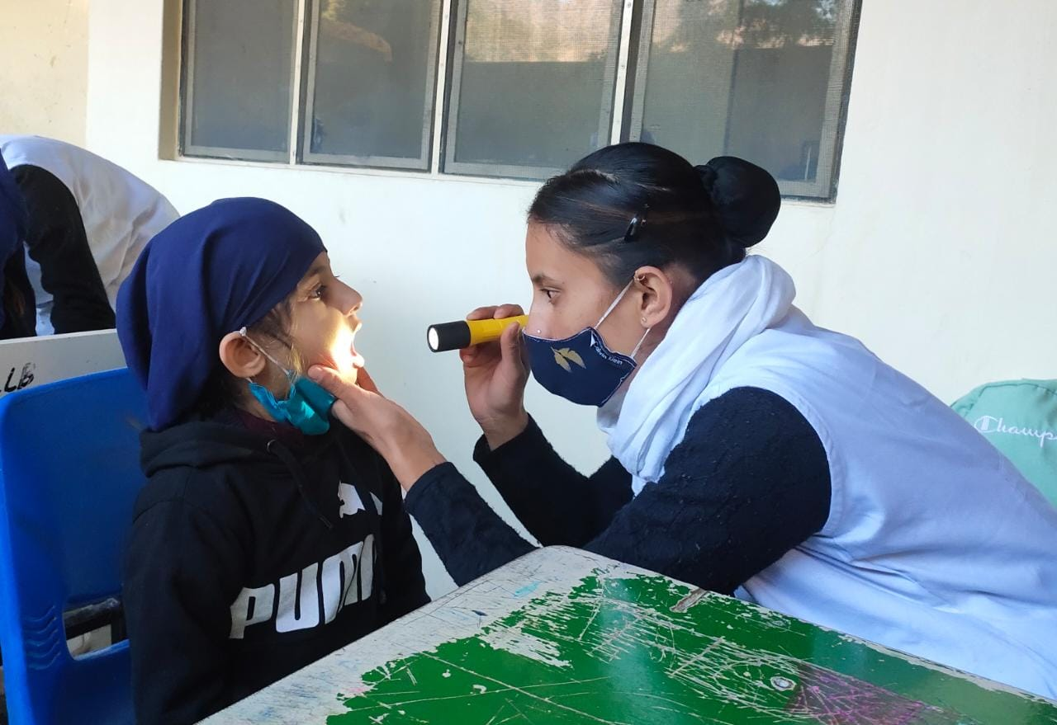
Respiratory:
SR.NO | RESPIRATORY PROBLEM | FREQUENCY | %
1 | Shortness of breath | 5 | 2.94
2 | Normal breathing | 165 | 97.05%

INFERENCES: Out of 170 students 2.94% have SOB .
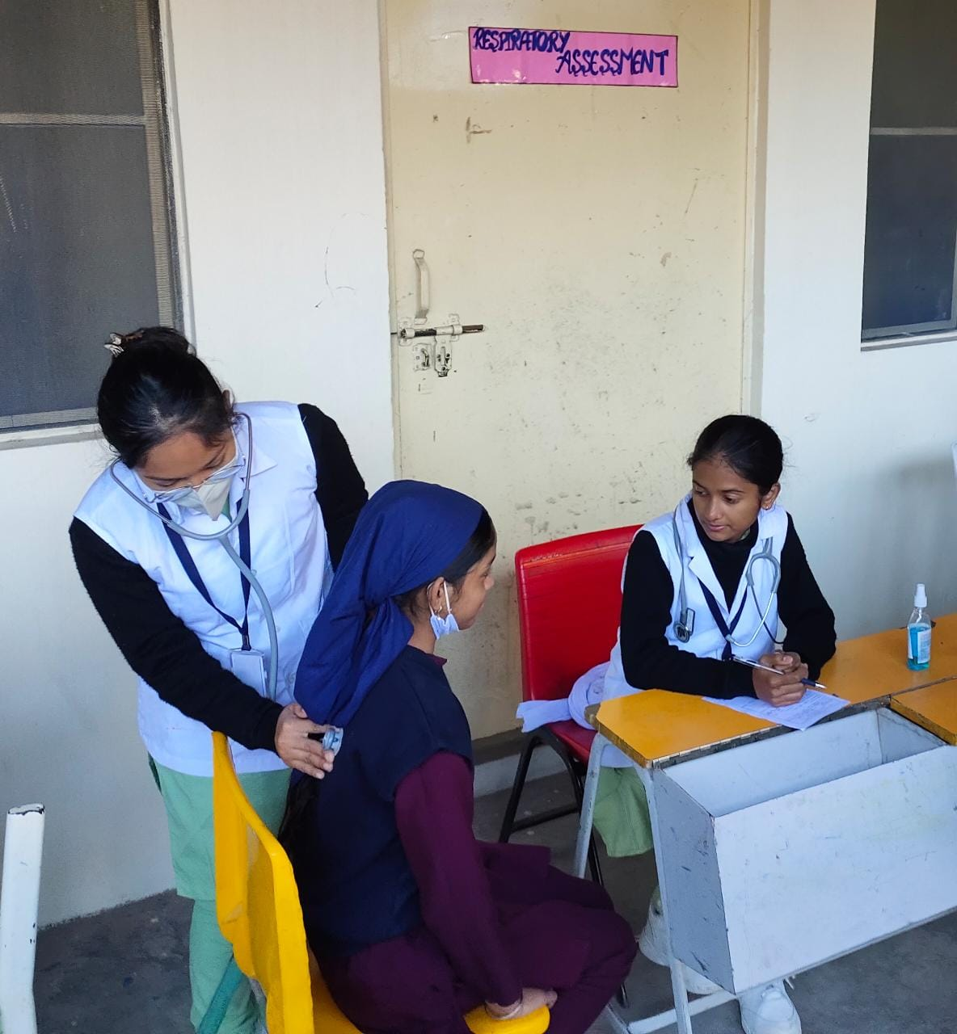
Eye
SR.NO | ABNORMALITY IN EYE | FREQUENCY | %
1 | Visual acuity | 11 | 6.47
2 | Blurry vision | 1 | 0.58

INFERENCES: out of 170 students 6.47 % are having visual acuity disturbance and 0.58% have blur vision
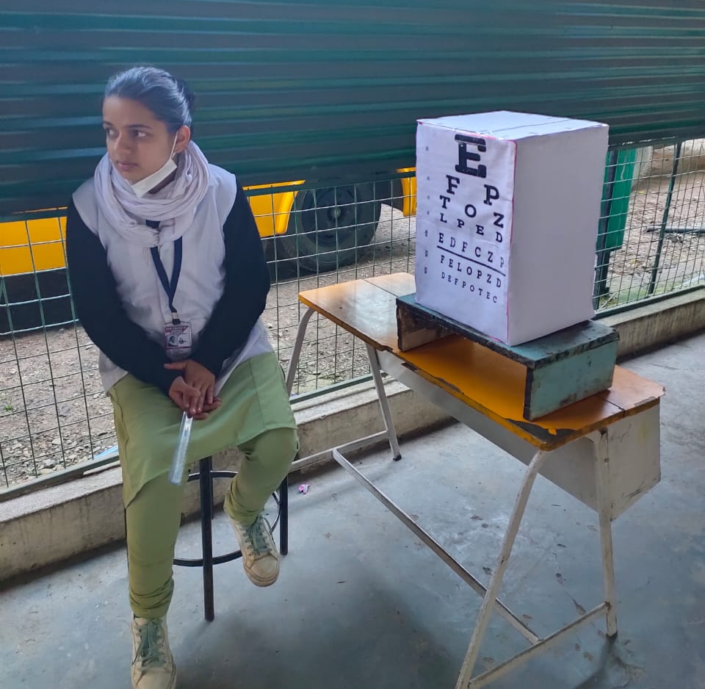

General consultation
SR.NO | GENERAL PROBLEMS | FREQUENCY | %AGE
1 | ANEMIA | 26 | 15.29
2 | SORE THROAT | 17 | 10
3 | DEHYDRATION | 24 | 14.11
4 | PAIN | 16 | 9.41

INFRENCE: out of 170 students 15.29% are having anemia , 10% are having sore throat , 14.11% are having dehydration and 9.41% are having pain.
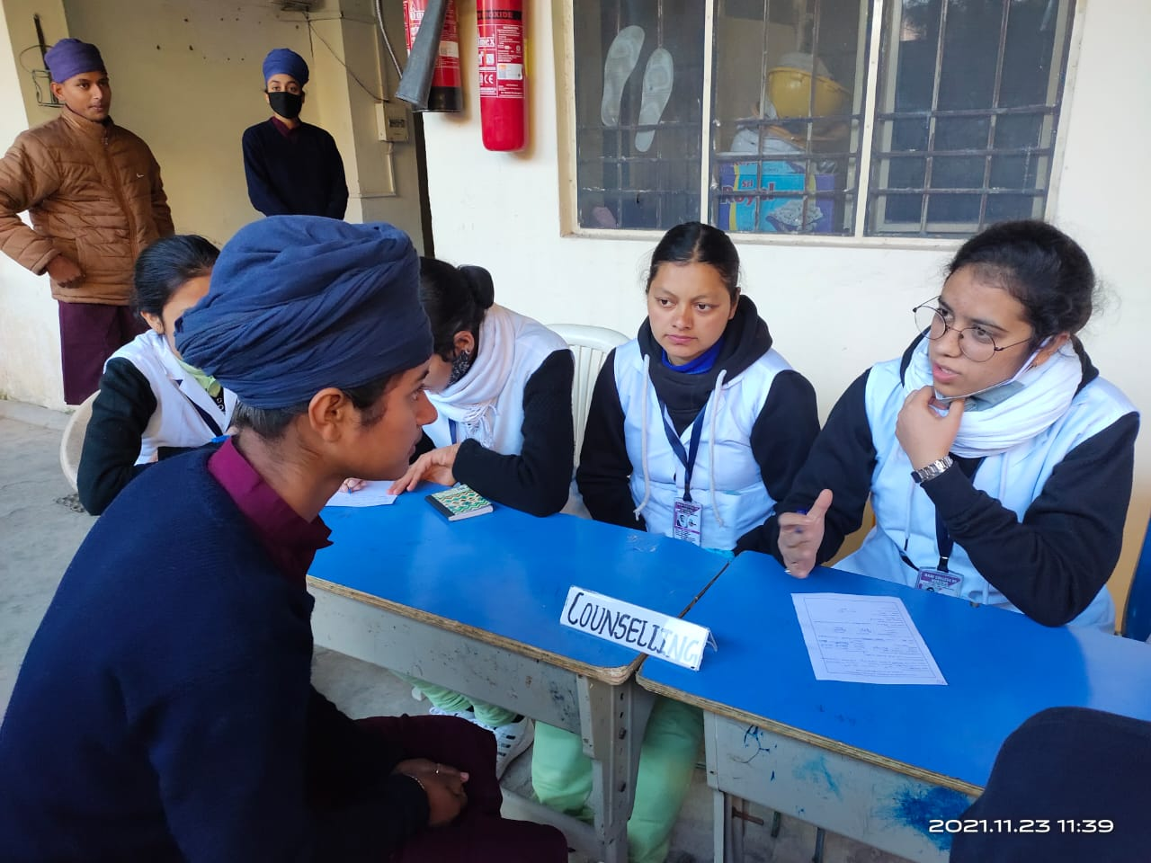
CONCLUSION:
After conducting health checkup we found that out of the total population of students i.e 170 none were having any serious health complication while a moderate number of children had common health issue.

DAY 3 : NUTRITION DAY
Food is the basic necessity of life. Everybody eats food and most people enjoy it. Life cannot be sustained without adequate nourishment. The concern of today’s health is the maintenance as well as the restoration of health. It may also be defined as the science of food and its relationship to health. It is concerned primarily with the part played by nutrients in body growth, development and maintenance.
On day 3 observed as a Nutrition day, we have done an exhibition on various nutritious diets by displaying the prepared foods, Nutrients chart and benefits were explained to the students. The following aspects were emphasized during the event:-
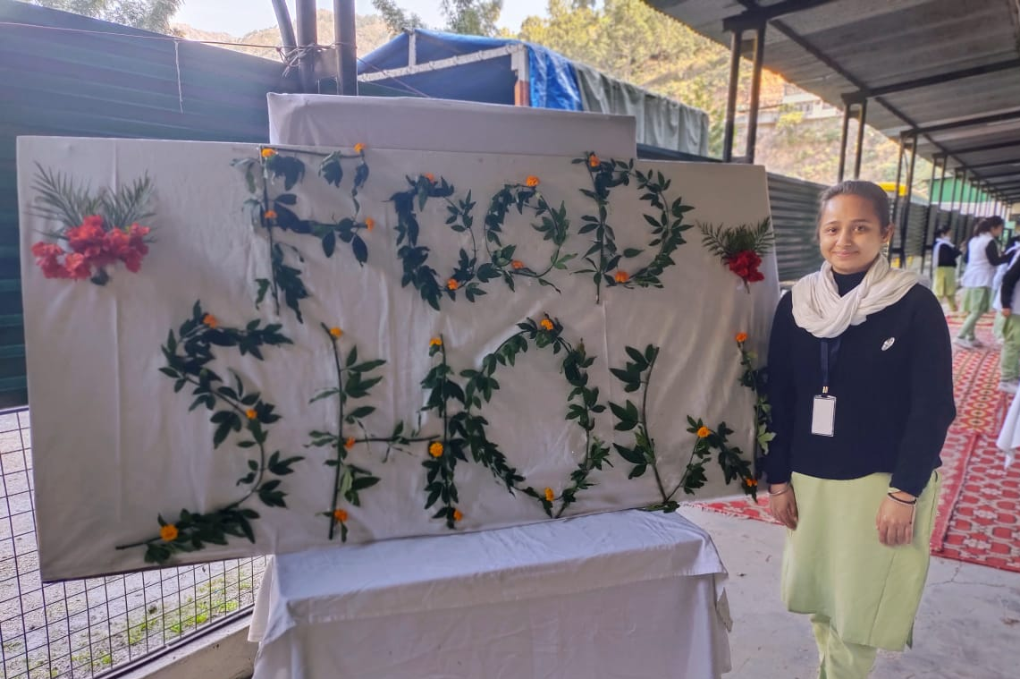

Nutrition: Nutrition is the science of food and its interaction with an organism to promote and maintain health.
Nutritional status: It is the condition of the body as it relates to consumption and utilization of food. It may be good nutrition or poor nutrition.
Good nutritional status: Good nutrition means ‘maintaining awell-balanced diet which supplies all the essential nutrients to meet the body’s requirements.
Poor nutritional status: Poor nutrition means ‘maintaining inadequate or even excessive intake of food.
Malnutrition: It refers to the physical effects on the human body of a dietary intake inadequately in quantity and/or quality.
Under nutrition: It refers to low food intake.
Nutrients: Nutrients are chemical compounds of food that supply nourishments to the body.
VEGETABLE SANDWICH
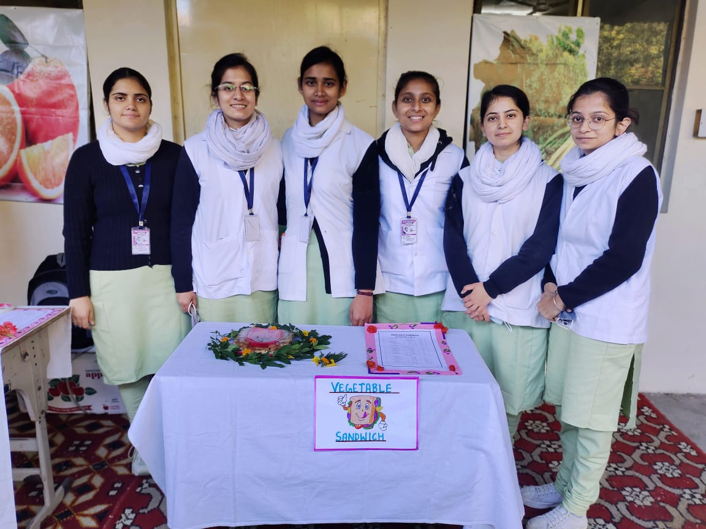
NUTRIENTS | VALUE PER SANDWICH | % DALY VALUES
ENERGY | 266 CAL | 13%
PROTEIN | 5.8 g | 11%
CARBOHYDRATES | 41.2 g | 14%
FIBER | 3.7 g | 15%
FAT | 8.7 g | 13%
CHOLESTROL | 25 mg | 6%
VIATMINS
VITAMIN A | 1098.5 mcg | 23%
VITAMIN B1 | 0.2 mg | 20%
VITAMIN B2 | 0.1 mg | 9%
VITAMIN B3 | 1.3 mg | 11%
VITAMIN C | 34.7 mg | 87%
VTAMIN E | 0.5 mg | 3%
FOLIC ACID | 31.2 mcg | 16%
MINERALS
CALCIUM | 51.8 mg | 9%
MAGNESIUM | 51.7 mg | 15%
IRON | 1.8 mg | 9%
PHOSPHOROUS | 60.4 mg | 10%
SODIUM | 118.8 mg | 6%
POTASSIUM | 225.1 mg | 5%
ZINC | 0.7 mg | 7%

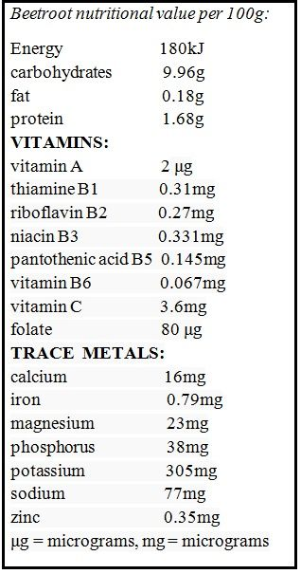
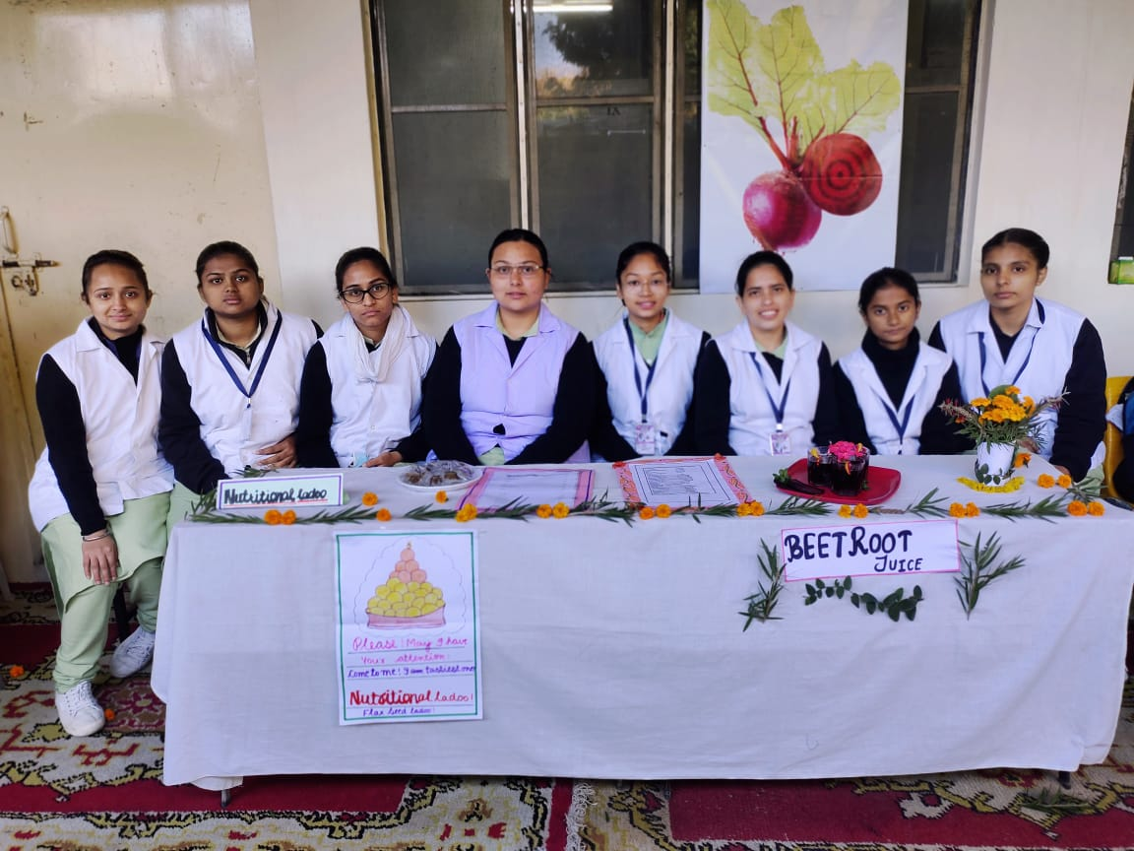
COCONUT LADOO
Nutrition Value

Amount per serving : 20g
Calories : 93.4Kcal
Net Carbohydrate : 2.8Kcal
Dietary Fibre : 1.7Kcal
Total Carbohydrate : 4.5Kcal
Total Fat : 7.3Kcal
Protein : 2.5Kcal
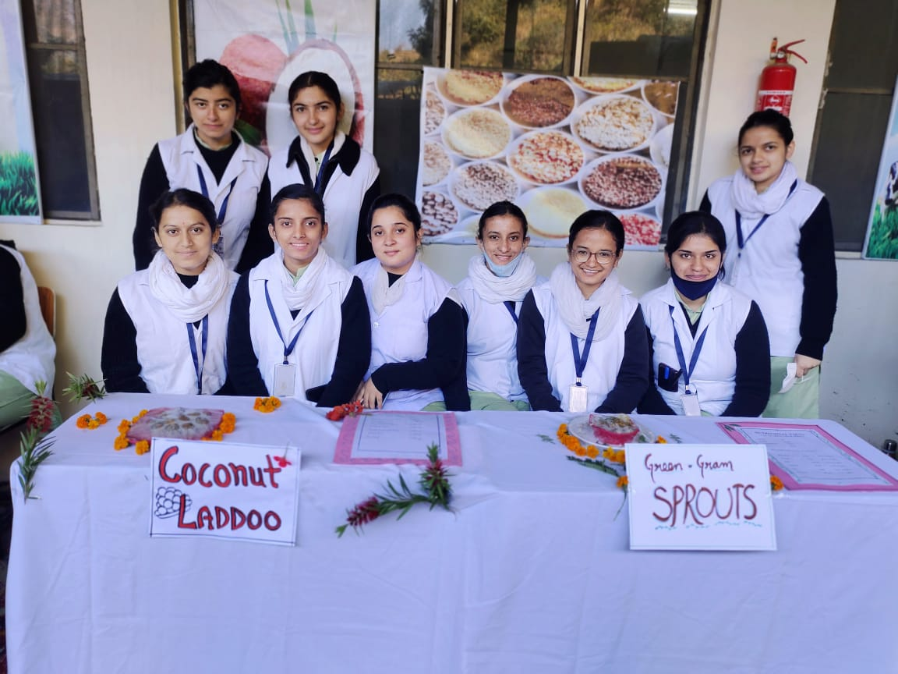

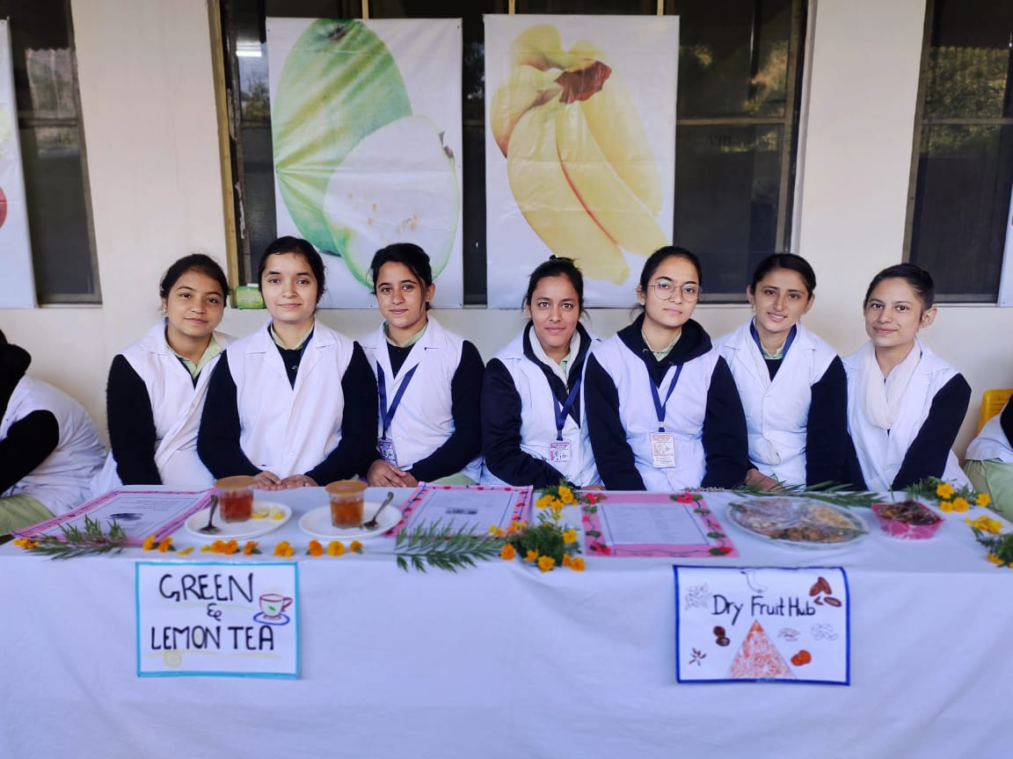
BENEFITS:
- Helps in regulating blood pressure
- Support immune system
- Stimulate weight loss
- Soothes toothache and cleanses teeth
- Assist in fever and cold relief
LEMON TEA
BENEFITS :
- Build stamina and immunity.
- Prevent tooth loss
- Reduce risk for cancer
- Reduce cholesterol
- Improves blood circulation
- Tones muscles and skin.
GREEN TEA
DRY FRUITS AND THEIR NUTRITIVE VALUES

[1]..Almond (28gm serving of almond)
. Protein 6gm
.Fiber 4gm
. Vitamin E 35%of RDA
. Mg 20% of RDA
. Cl 8% of RDA

[2]..Cashews(kaju)
.Protein 5gm
. Fiber 1gm
. iron 11% of RDA
. Copper 67% of RDA
. Carbs 9gm of RDA
. Fat 12gm
. 157 calories

[3]..Dates (7gm serving )
.Protein 0.2gm
.Fiber 0.6 gm
.Sodium 0.14 mg
.Carbs 5.3gm
.Calories 20

[4]..Walnuts (28 gm of serving)
.Protein 4.3 gm
.Fiber 1.9 gm
.Carbs 3.9 gm
.Fats 18.5 gm
.Suger 0.5 gm
.Calories 185

[5]..Raisins (kishmish)(28 gm of serving)
.Protein 0.5gm
.Fiber 0.6gm
.Sodium 3.6gm
.Carbs 11gm
.Suger 9.1 gm
.Calories 42

[6]..Peanuts (100gm)
.Fat 49 gm
.Sodium 18mg
.Potassium 705mg
.Carbs 16 gm
.Protein 26 gm

1. | TOTAL FAT | 0
2. | CHOLESTEROL | 0
3. | CARBOHYDRATES | 0.2g
4. | SUGAR | 0
5. | PROTEIN | 0.2
6. | VITAMIN C | 6mg
7. | IRON | 0.2mg
8. | CALORIE | 0

AMOUNT IN 1CUP OF CHICKPEA

Energy(Calories) : 267
Protein (g) : 14.4
Fat(g) : 4.2
Carbohydrate(g) : 44.7 including 7.8g of sugar
Fiber(g) :12.5
Calcium (mg) :80.4
Iron (mg) :4.7
magnesium (mg) :78.7
Phosphorus (mg) :274
Potassium (mg) :474
Zinc(mg) : 2.5
Copper (mcg) :0.6
Selenium (mcg) : 6.1
Vitamin C(mg) :2.1
Folate (mcg) :280
Choline (mg) :69.7
Beta carotene(mcg) :26.2
Vitamin E(mg) :0.6
Vitamin k(mcg) :6.6

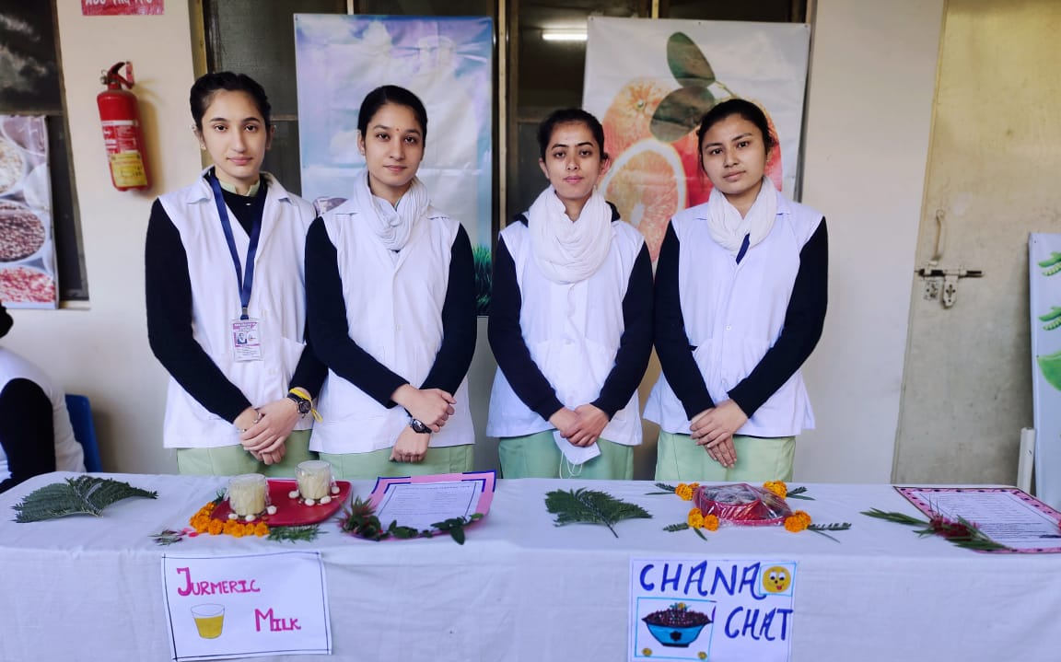

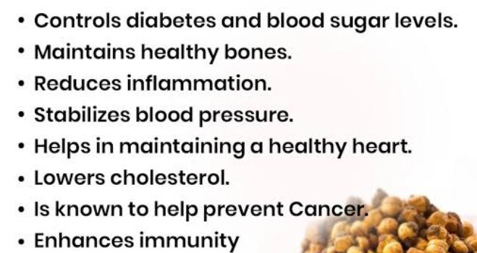
NUTRITATIVE VALUE OF FRUIT SALAD
APPLE
- Calories 95 kcal
- Fibers 4.4 gram
- Protein 0.5 gram
- Fat 0.3 gram
- Carbohydate 25 gram
BANANA
- Energy 89kcal
- Protein 1.1gram
- Carbohydrate 23gram
- Fat 0.3gram
- Fiber 2.6gram

GUAVAVA
- Protein 4.2gram
- Fiber 8.9gram
- Fat 1.6gram
- Calories 112kcal

POMEGRANATE
- Calories 128kcal
- Fiber 6gram
- Protein 3gram
- Fat 2gram
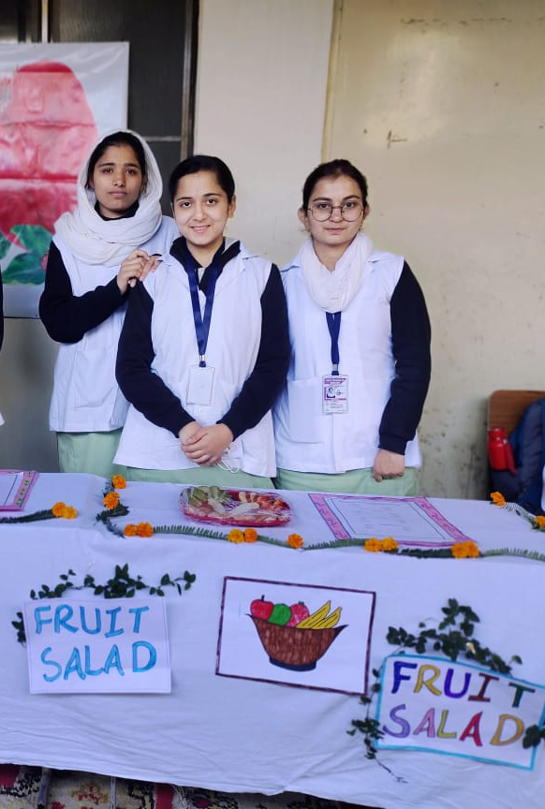
NUTRITION FACTS
Amount per serving
- Calories 99.93
- Calories from fat 25.11
- Total fat 2.79 gram
- Cholesterol 5.52mg
- Sodium 54.88mg
- Carbohydrate 13.91gram
- Fiber 1.27gram
- Protein 3.49gram
- Vitamin A 295.74mcg
- Calcium 24.71mg
- Vitamin C 606.4mg
- Iron 0.21mg
- Potassium 77.95mg
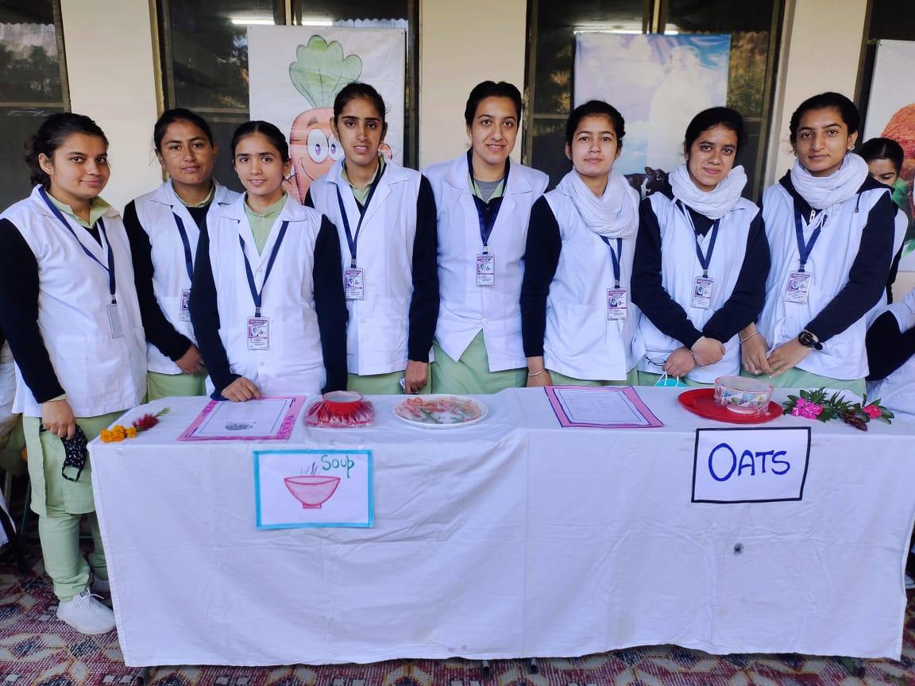

NUTRITIONAL FACTS 1CUP OF GREEN GRAM SPROUT

Calories : 217
Protein : 15.6g
Carbohydrate : 36.8g
Fat : 0.84g
RECOMMENDED DAILY ALLOWANCE
High fiber : 10.85g : 43.4% of RDA.
Protein : 15.6g : 28.4% of RDA
Zinc : 1.95mg : 19.5 % of RDA
Calcium : 80.6g : 13.4% of RDA
Iron : 2.86g : 13.6% of RDA
Potassium : 547 mg : 11.6 % RDA.
NUTRITIVE VALUE OF TURMERIC MILK

Energy 255kcl
Protein 8.6g
Carbohydrate 15.8g
Fiber 0g
Fat 13g
Cholesterol 32 mg
Vitamins
Vitamin A 320mcg
Folic Acid 11 mcg
Minerals
Calcium 420.4mg
Iron 0.4mg
Magnesium 38.1mg
Phosphorus 260.3mg
Sodium 38.3mg
Zinc 0.6mg

BENEFITS OF TURMERIC MILK
- Clears the skin
- Helps in digestion
- Purifies the blood
- Boost heart rate
- Improves blood circulation
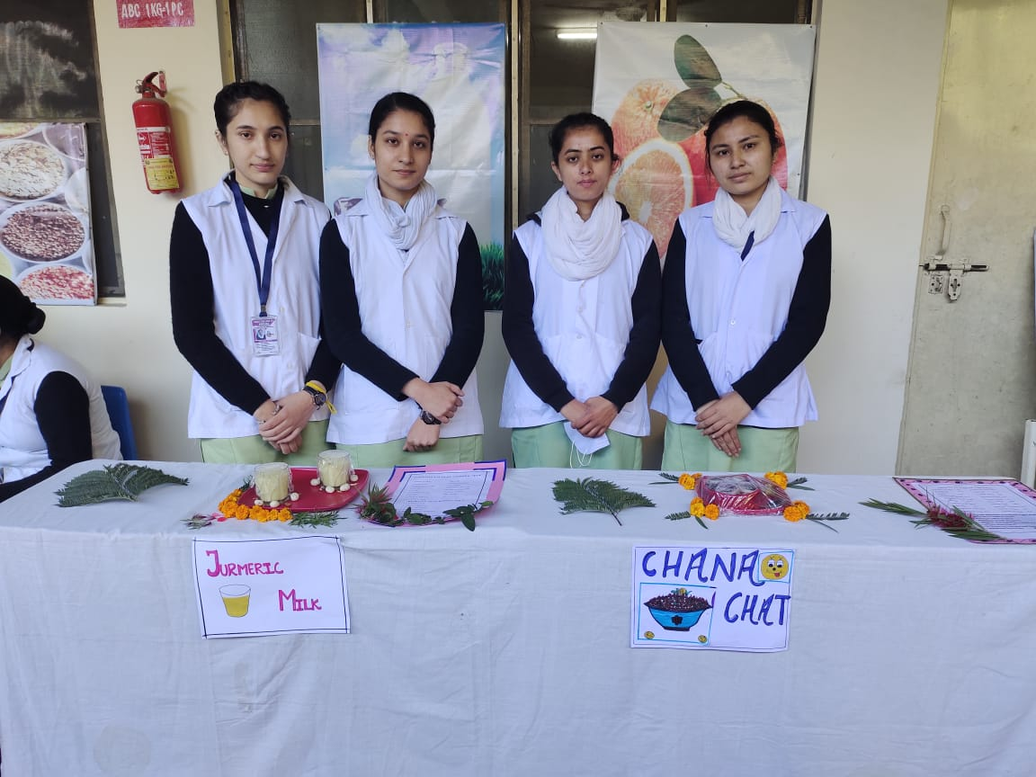

QUAKER OATS – OATS W/ MILK/SUGAR
Serving size : 1 cup
TOTAL CALORIE : 436 cal
72% carbohydrate, 12% fat, 16% Protein
Nutritional Info

Carbs 80g
Dietary Fiber 8 g
Sugar 26g
Fat 6 g
Saturated 1 g
Polyunsaturated 2 g
Monounsaturated 2 g
Trans 0 g
Protein 18 g
Sodium 130 mg
Cholesterol 5 mg
Vitamin A 10 %
Vitamin C 4 %
Calcium 30 %
Iron 20%

JUNK FOOD

HARMFUL EFFECTS
- Obesity
- Cardiovascular disease
- Learning and memory problems
- Loss of appetite and digestion
- Mental impact leading to depression
- Inadequate growth and development
DAY 4 : TEACHERS MEETING
On day 4 teachers meeting was conducted for Model School teachers regarding the health problems identified through Health Checkup and Observation of the School.
Ms. Prakchi & Ms. Sheena and Ms. Tstakshi 4th year B.Sc.(N) students Leader were presented the detail report on Observation of school with regard to Health and safety of the students. Recommendations were discussed with the teachers.
DAY 5 : HEALTH EDUCATION PROGRAM
On day 5 Mass Health Education Program was conducted for Model School Children based on the health problems identified through Health Checkup and Observation of the School.
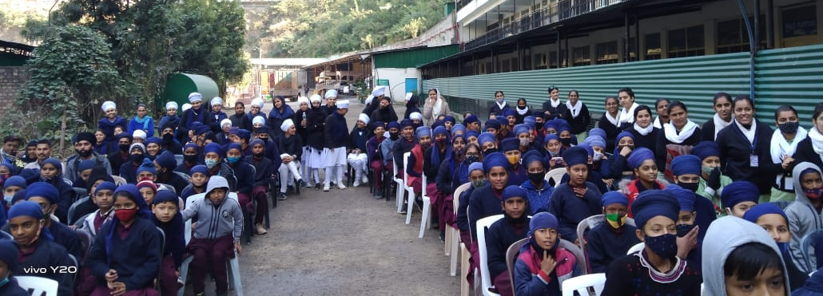
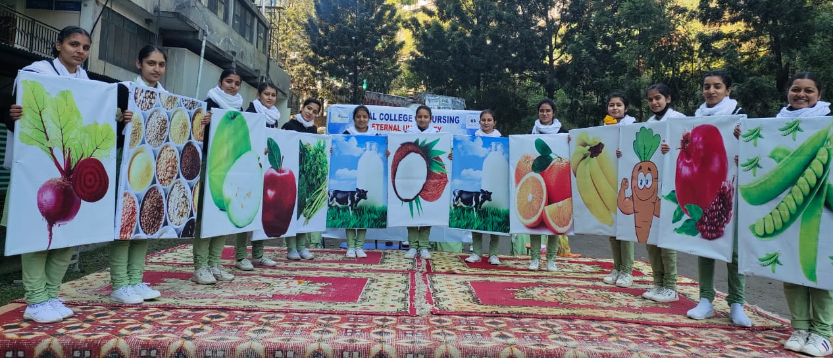
Ms. Prakchi & Ms. Sheena and Ms. Tstakshi 4th year B.Sc.(N) students Leader were welcomed the gathering and Dr. Raina, I/c Principal, Model School, felicitated the gathering as a Chief Guest of the Program. The students were actively participated in the quiz competition and they were awarded with prize.

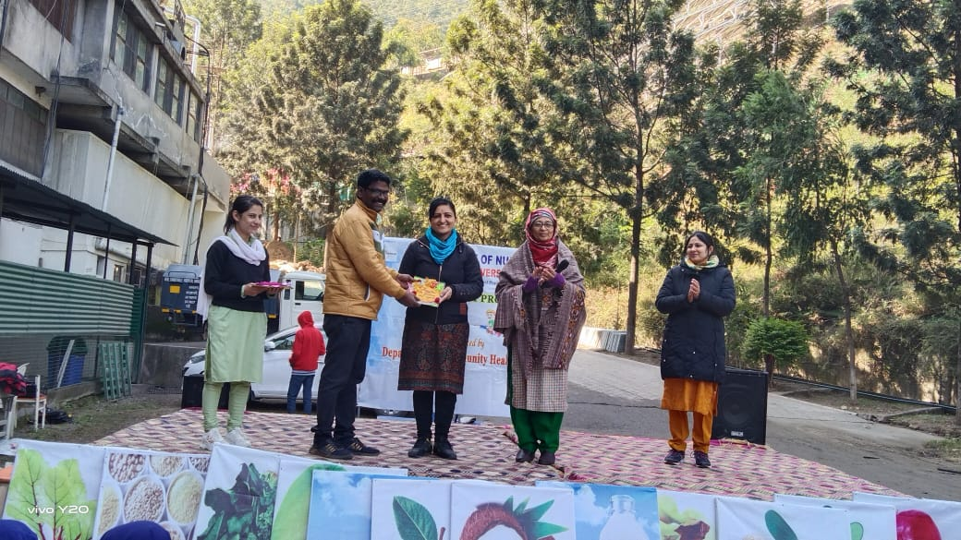
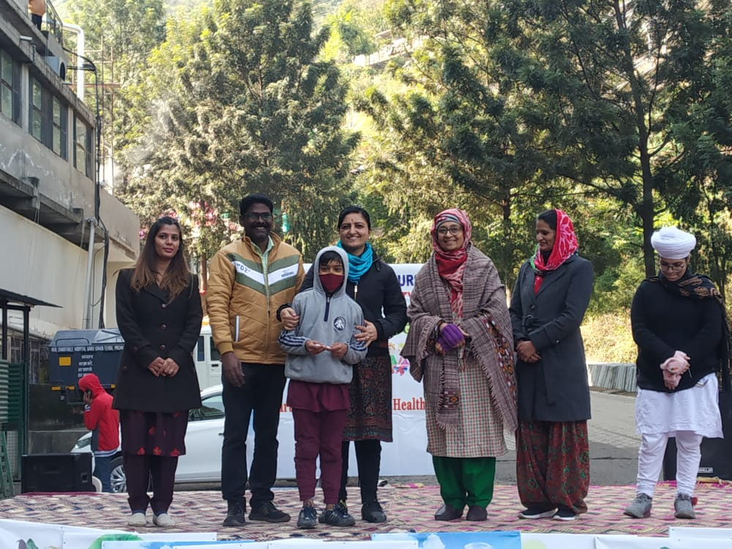

Health Education on Reproductive and Sexual Health and Menstrual Hygiene was given to the adolescents girls of Model School.
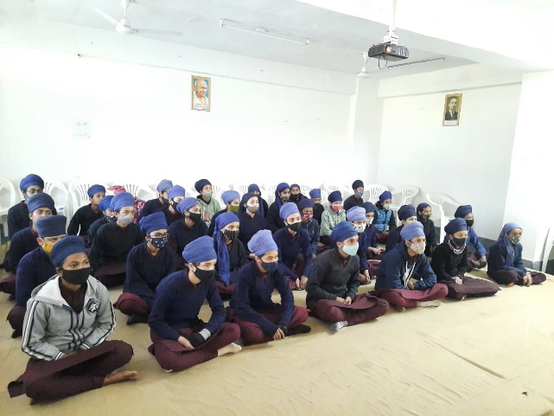
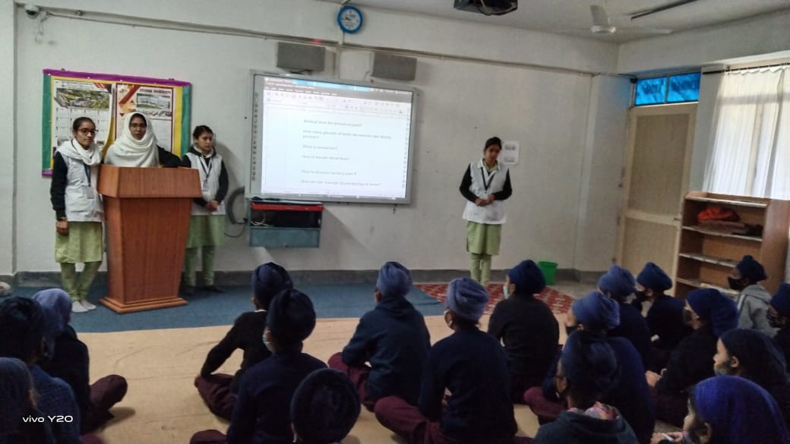

CONCLUSION
We conducted school health program from 22/11/2021 to 26/11/2021 after getting the formal permission. We involved 270 students for school health program among them 170 students were participated in basic health checkup. During this program we have involved in health Checkup and School environment observation for health and safety of the student studying at the school. We have conducted Food exhibition for healthy food habits and benefits of good nutrition were thought to the students. And we have organized Teachers meeting and Mass Health Education program for the students based on the health problems identified among the students.

